Y11 GCSE Information Evening
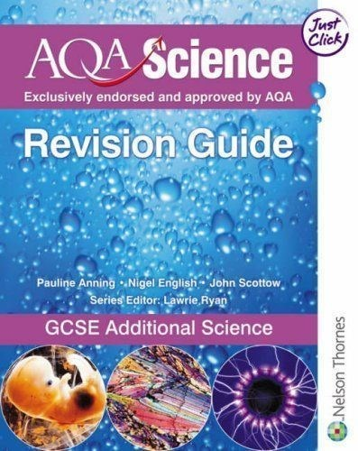
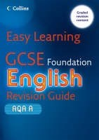
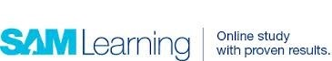
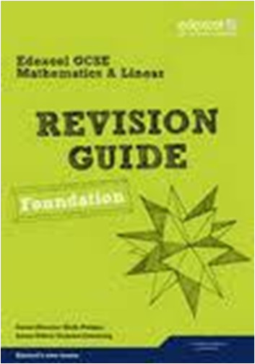

Art and Design
Exam Detail | There will be a full mock exam in preparation for the GCSE and work completed over the two day exam will form part of the 60% course work unit.  The exam title (40%) will be issued around Easter time and students have approx. 6 weeks to prepare for the exam. The approach is very similar to coursework and a final piece/s will be produced over two days under controlled conditions.
Coursework Deadlines | One unit of coursework over two sketch books,covering two different titles.  Completion of all coursework by hand in date after exam which is usually in April (date to be confirmed).  Students will be expected to come in and put up an exhibition of their work usually early June for the external moderator to mark the work.
Revision Guidance | Targeted sessions for catch up and coursework guidance are on Monday and Wednesday after school in the Art Department. Students are welcome to work after school independently in the department after school.
What can I do? | Help with ideas from the words given, aid with research tasks.  Maybe visit a gallery or exhibition.  Ensure your daughter has all the equipment she needs.  A quiet space to do Art work preparation.  Encourage her to stay after school for extra art.
Useful Websites | www.nationalgallery.co.uk www.art2day.co.uk www.studentartguide.com  www.tate.org.uk
ADVICE FOR STUDENTS:  What do I need to do to succeed in this subject? | Keep up to date with all the work that your teacher sets. Be independent in your working practice and use research of other artists to inform your own ideas.
What do I need to do to excel in this subject? | You need to put in the time to ensure that your ideas are well explored are researched.  Use your teacher’s expertise and do not be afraid to ask for help and advice.

Business Studies
Exam Detail | AQA Examining Board  Unit 1 and Unit 2 exams in June of Year 11  Unit 2 covers the following topics: Year 11 Curriculum  · Growing as a business  · Marketing  · Finance  · People  · Operations Management  End of topic tests intermittent throughout year
Controlled Assessments | Completed in Y10.
Revision Guidance | BBC GCSE Bitesize www.tutor2u.net  Staff available at lunchtime or break time
What can I do? | Help your Daughter to remember information from the lessons by going over classwork with her.  Learn how she revises best and encourage her with this method. Make sure your daughter completes work by the set deadlines.
Useful Websites | School VLE Business Studies KS4.  http://www.bbc.co.uk/education/subjects/zpsvr82  http://www.tutor2u.net/#business  www.beebusinessbee.co.uk
ADVICE FOR STUDENTS:  What do I need to do to succeed in this subject? | Become an independent learner, watch the news and read a quality newspaper each week  Also ensure that you are up to date with all class and homework tasks set.
What do I need to do to excel in this subject? | Review your weekly notes.  Make revision cards early.  Repetition - commit your knowledge by reviewing work set regularly – once a week on rotation

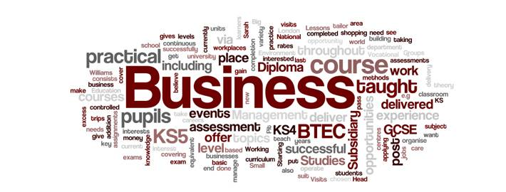

Exam Detail | WJEC catering exam is 40% of the mark 1hr.15 min  2nd Practical exam January 2016 2 ½ hours.
Coursework Deadlines | Beginning of March 2016 60% of final mark
Revision Guidance | Revision book for WJEC GCSE that students can buy through school £8.00. Revision questions on Student VLE  Topics for written paper  Catering terminology  Food preparation and commodities  Industry & job roles  Health and safety  Diet and nutrition  Types of service  Menu planning  Environmental issues  Legislation
What can I do? | Ensure your daughter has ingredients for trial dishes which are part of their research for their practical exam.  She needs to be well organised for trials and practical exams, bringing ingredients when needed and weighed out. Check everything is ready the night before. She may need containers and/or dishes to carry food home safely and a clean apron.  Practice dishes at home, so they feel confident when they go into their catering exam. Help with research into different recipes and cuisines from around the world. Encourage the cooking and eating of different foods at home, especially foods from different countries and cultures.
Useful Websites | Www.nutrition.org.uk  Www.bbcgoodfood.com/content/recipes  Www.eatwell.gov.uk  Www.foodafactoflife.org.uk  Www.5aday.nhs.uk  Foodbycountry.co.uk
ADVICE FOR STUDENTS:  What do I need to do to succeed in this subject? | Complete coursework to deadlines and keep focused in controlled assessment time, so that you do not waste time and work to your best ability. Do as much independent research to improve your coursework grades. Always practice dishes at home prior to the practical exam, research dishes using high level skills.
What do I need to do to excel in this subject? | Use high level cooking and presentation skills in practical exams, so can gain high marks for practical exam. Listen to advice from teachers for the practical exam when trialling, so that you can adapt dishes to gain good marks. Keep to deadlines with coursework. Revise using revision books. CGP WJEC Catering study and Exam Practice and Hodder WJEC GCSE Hospitality and catering revision, so can answer higher mark questions fully.
Catering

Health and Social Care
Exam Detail | BTEC/Pearson  Exam : Summer – end of Year 10  Resit Exam – January Year 11  Exam Unit – worth 25 % of overall qualification  Topic covered in exam  Human Lifespan Development
Other Assessment | Coursework Units 2, 5 & 7  Health & Social Care Values  Promoting Health & Well Being  Equality & Diversity in Health & Social Care  Coursework Units – worth 75 % of overall qualification
Revision Guidance | Revise BTEC – BTEC First Revision Guide – Pearson  Revise BTEC – BTEC First Revision Workbook – Pearson  Staff available to speak to students at break times, lunch times and after school.  After school coursework catch up and revision time – Weekly Mondays 3.10pm to 4pm
What can I do? | Ensure coursework is up to date and all hand in dates are met
Useful Websites | BTEC First Health & Social Care – Pearson  http://www.bbc.com/news/us/health
ADVICE FOR STUDENTS:  What do I need to do to succeed in this subject? | Meet all coursework hand in deadlines to ensure the higher grading criteria can be met. Complete practice papers for the exam
What do I need to do to excel in this subject? | Complete all tasks to Distinction level

Child Development
Exam Detail | BTEC/Pearson  Exam : Summer – end of Year 10  Resit Exam – January Year 11  Exam Unit – worth 25 % of overall qualification  Topic covered in exam  Patterns of Child Development
Other Assessment | Coursework Units 2 & 3  Promoting Children’s Development through Play  The Principles of Early Years Practice  Coursework Units – worth 75 % of overall qualification
Revision Guidance | Revision Resources on School VLE  Staff available to speak to students at break times, lunch times and after school  After school coursework catch up and revision time – Weekly Mondays 3.10pm to 4pm
What can I do? | Ensure coursework is up to date and all hand in dates are met.
Useful books/Websites | Penny Tassioni – Children’s Play Learning and Development BTEC First ISBN 878 1 447944 61 4  http://www.nurseryworld.co.uk/
ADVICE FOR STUDENTS:  What do I need to do to succeed in this subject? | Meet all coursework submission deadlines to ensure the higher grading criteria can be met. Complete practice papers for the exam
What do I need to do to excel in this subject? | Complete all tasks to Distinction level.
DT Product Design
Exam Detail | AQA  Design and Technology:  Product Design  One x 2 hr paper in May/June 2017.  Pre-release theme will be issued in March 2017.
Coursework Deadlines | Final hand in for controlled assessment folder and practical.  Make and folder, up to final evaluation Fri 10th March.  Final evaluation Friday 24th March  Worth 60% of final GCSE.
Revision Guidance | Yr11 Mock exam during mock exam week.  Nelson & Thornes  AQA GCSE D&T Product Design, Textbook already provided.  GCSE Bitesize and SAM Learning.  All Y11 students can attend the Controlled Assessment Clinic every Tuesday after school 3:15—4:30pm.
What can I do? | Help with research of topic themes.  Practice key words together.
Useful Websites | technologystudent.com www.designmuseum.org www.designweb.co.uk www.tep.org.uk designandtech.com  www.design-technology.org  School VLE / PLC page.
ADVICE FOR STUDENTS:  What do I need to do to succeed in this subject? | Talk to your teacher as soon as needed about anything that will help!
What do I need to do to excel in this subject? | Manage your time well and keep up with all the interim and final deadlines.  Use your folder diary to keep track of progress and to help final write ups.

Drama
Exam Detail | Units 1 & 2 teacher marked/assessed course work (both practical and written).  The practical exam is assessed by an external examiner who watches an evening performance. The exam will happen in year 11 by the end of the Spring term.
Coursework Deadlines | Unit 1 and 2 C/W to be completed in controlled after school sessions by the end of January 2017
Revision Guidance | Learning lines for practical examination  Attending additional rehearsals after school, weekends and in school holidays all TBC via parent letters.  Attendance in school is vital for rehearsals and the support of your groups in performances.
What can I do? | Help your daughter to learn any lines.  Try to visit a live show to gain experience of the theatre.
Useful Websites | Students should access the VLE
ADVICE FOR STUDENTS:  What do I need to do to succeed in this subject? | Maintain a positive attitude and an inquisitive mind. Be willing to work with others effectively and experiment with different theatrical forms and techniques.
What do I need to do to excel in this subject? | Visit a range of live theatre productions regularly. Conduct wider reading of theatre practitioners and styles, and read professional theatre reviews.

Languages
Exam Detail | Listening and reading skills will be examined at Foundation and Higher level in summer 2017.  GCSE Listening and Reading papers:  French 16th May 2017  Spanish 19th May 2017  German 7th June 2017  Italian 16th June 2017
Coursework Deadlines | At the moment your daughter will be preparing for writing/speaking Controlled Assessments.  Most students will have completed 3 writing assessments and 3 speaking assessments by February 2017 and this will count for 60% of their qualification.  Some students will be given the option to complete a 4th piece after February.  Practice for the reading and listening papers will take place in lesson time.
Revision Guidance | Use the school VLE.
What can I do? | For controlled Assessments:  Check that your daughter hands her work in on time to be marked by her teachers.  Test your daughter before her test (check she has learnt the material accurately)  For the reading and listening exam:  Encourage her to revise her vocabulary for the different topics (vocabulary lists can be found in the text books).  Encourage the use of revision material.  Make sure she attends extra revision sessions.  Check that homework is being completed as this will be set on a weekly basis throughout Y11.
Useful Websites | www.bbcbitesize.co.uk www.linguascope.com www.atantot.com  samlearning.com  Passwords to be obtained from the language department.
ADVICE FOR STUDENTS:  What do I need to do to succeed in this subject? | Ensure that all assessed work meets your target grade.  Learn all vocabulary on a regular basis.
What do I need to do to excel in this subject? | Complete a third piece (of either writing or speaking) in order to improve.  Spend time on extra grammar activities.

Exam Detail | OCR SHP History “A”  Paper 1: Medicine Through Time and Germany 1918-45.  Paper 2: 19th century Public Health Source Paper.
Coursework Deadlines | End of Y10
Revision Guidance | Much material on the VLE, including summary power points.  Start revising early by looking over medicine and making sure you know where your books are from year 10.  There are many commercial revision guides for these popular courses.  Past paper question practise.
What can I do? | Help with revision planning.  Look through books from Y10 and Y11 and make sure there are no gaps-use PLC to help with this.  Purchase a revision guide
Useful Websites | BBC Bitesize  JohndClare.net  OCR website  There are more links on the History page of the student VLE.
ADVICE FOR STUDENTS:  What can I do to succeed in this subject? | Plan revision carefully.  Allow time to cover all the content.  Try to learn 5 key facts about each topic.  Ensure you practise exam technique in how to answer the questions
What can I do to excel in this subject? | Use a detailed revision guide such as Heinemann rather than CGP  Read around the subject using the reading list on the VLE.  Practice writing in timed conditions and making sure that you have detailed notes on every topic-you need to learn more than 5 key facts to really excel.
History

Geography
Exam Detail | Edexcel B GCSE Geography  3 exams and Controlled Assessment  Unit 1 = 25%  Unit 2 = 25%  Unit 3 = 25%  Unit 4 = 25% of GCSE Controlled Assessment completed.
Coursework Deadlines | Controlled Assessments year 11 completed.
Revision Guidance | There will be revision resources on the VLE for you to use in end of topic tests. You will also find some exam questions to practice. You should go through your PLC and make flash cards or posters. You should also test yourself on key words! SAM learning might also help. Don’t just read through your folder, this isn’t very effective!
What can I do? | Help with revision planning.  Look through folders from Y10 and Y11  Use PLC’s  Make case study cards  Complete past papers  Purchase a revision guide Hodder Education, My revision notes, Edexcel B GCSE Geography.
Useful Websites | The school VLE  bbcbitesize  Edexcel B (for past paper questions)
ADVICE FOR STUDENTS:  What can I do to succeed in this subject? | Complete all work on time and to the best of your ability.  If you are away, ensure that you catch up with missed work form the VLE.  You must make neat notes and keep them in good order. It will make them easier to revise from.  Act on feedback from your teacher (DIT)  You should keep track of your progress on your tracking sheet.  If you don’t understand something/need extra help please ask one of the geography teachers, they will be happy to help
What can I do to excel in this subject? | Top geographers keep an eye on the world around them. They know about current global issues and develop opinions on them. In their exam answers they fully explain their points, use detailed examples and express their opinion.

RS Short Course/Full Course
Exam Detail | SC—1 exam, 1 hour 30 minutes: Religion and Morality (AQA 4056/40553)  FC— 2 exams both 1 hour 45 minutes: (i) Religion and Life  Issues, and (ii) Religion and Human Experience
Revision Guidance | SC AND FC  The departmental VLE folder contains a lot of useful materials for the SC, including revision booklets, past question papers, and model answers.  There are also materials for the FC.  Effective revision for RS&P includes learning quotations and revising technical vocabulary. Plenty of timed essay practice is also advisable – it helps you hone your exam technique.
What can I do? | It is helpful if parents can discuss at home some of the moral and life issues with which pupils engage at home.
Useful Websites | School VLE samlearning.com
ADVICE FOR STUDENTS:  What can I do to succeed in this subject? | Make sure she attends all lessons.  Complete ALL pieces of homework.  Catch up on any work missed.
What can I do to excel in this subject? | Complete OLA’s on Show My Homework.  Look up passages in the holy texts that we may not have covered in class.

Computing
Exam Detail | OCR GCSE Computer Science  Computer systems and programming. This is assessed by a written paper, which has a mixture of short- and long answer questions, some of which require students to write program code.  Examined unit – 7 June 2017 1hr 30mins
Coursework Deadlines | Practical investigation. This will be on a topic chosen from a set of options supplied by OCR (controlled assessment).  Programming project. Students create solutions to computing tasks chosen from a set of options supplied by OCR (controlled assessment)  February 2017
Revision Guidance | VLE > Departments>computing> Ks4> computer science PLCs  www.ocr.org.uk/computing  www.code.org  Sam Learning  Completed presentations  Theory E-book
What can I do? | Ensure your daughter knows the deadlines for the course.
Useful Websites | School VLE  www.teach ICT.com  www.ocr.org.uk/computing  www.code.org  Sam Learning
ADVICE FOR STUDENTS:  What can I do to succeed in this subject? | Use and review PLCs to plan revision carefully.  Allow time to cover all the content.  Do as many past paper questions as possible to help improve exam technique.
What can I do to excel in this subject? | For controlled Assessments:  Ensure that work is submitted on time.  For the Written exam:  Make sure you attend any extra revision sessions.  Make sure you are constantly recapping key terminology.  Find real life examples to help remember theory.

AS/A2 ICT
Exam Detail | AQA  INFO1 - 05 June 2017 am Written Exam - 1h 30m  INFO2 - 09 June 2017 am Written Exam - 1h 30m  INFO3 - 16 June 2017 am Written Exam - 2h
Coursework Deadlines | INFO4 – final coursework deadline 17th March 2017
Revision Guidance | Textbooks will also be provided to each student. Online resources and VLE.
What can I do? | Personalised learning checklists for both units are available on the VLE.
Useful Websites | www.teach-ICT.com  VLE>ICT page—key stage 5>AS
ADVICE FOR STUDENTS:  What can I do to succeed in this subject? | Use and review your PLCs to plan revision carefully.  Allow time to cover all the content.  Do as many past paper questions as possible to help improve exam technique.
What can I do to excel in this subject? | For coursework:  Make sure that your work is submitted on time For the Written exam:  Make sure you attend any extra revision sessions.  Make sure you are constantly recapping key terminology.  Find real life examples to help remember theory.

Exam Detail | Unit 1—Investigation into media  Written paper—1hour 30 minutes—60 marks = 40%  External Assessment  Based on pre-release topic (changed annually) with guidance and stimulus.  Four Tasks (including a practical planning task)  Pre-release given to students 25/4/16  Unit 1 Exam: 24/5/16  Exam topic: SCIENCE FICTION FILMS  Unit 2—Understanding the Media  Controlled Assessment taken from banks of set assignments—90 marks = 60%  Three assignments:  advert analysis + own advert cross platform analysis of a reality TV show + poster/ storyboard planning for own reality TV show music video planning, production and evaluation. Unit 2 assignment 1, 2 and 3 to be complete by 5/2/16
Coursework Deadlines | Friday 2nd February for all coursework. This is the final submission for a final assessment to be made.  Compulsory editing sessions to complete the music video coursework will take place from Oct – Jan after school on Tues/ Thursday. Students will be informed which sessions they are attending.
Revision Guidance | Media department VLE media studies—GCSE-Unit 1–Science Fiction  (resources added throughout the year)  GCSE Media Studies: Revision Guide, Richard Parsons (good for very basic media concepts)  AQA GCSE Media Studies Student book by Richard Morris & David Varley, Nelson Thornes, (26 May 2009)
What can I do? | Ensure deadlines are met.  Watch a range of science fiction films to familiarise yourself with the genre.  Complete your PLCs at various points during the year.  Revise as you go – you have a lot of content to learn, so you should revise each aspect of science fiction films as we learn about them in lessons.
Useful Websites | www.mediaknowall.co.uk
ADVICE FOR STUDENTS  What can I do to succeed in this subject? | Thoroughly understand and apply the key concepts (media language, representation, audience, institution) and respond quickly to a media brief with her prepared response. Keep on top of deadlines and be prepared to go ‘the extra distance’ when creating media products.
What can I do to excel in this subject? | Prepare for every scenario in the exam understanding the full range of questions that could be asked and knowing how to respond in each eventuality. Understanding more complex media theories will help enhance marks further.
Media

Music
Exam Detail | The final exam will be held in the summer of 2017 date TBC.  The exam will last for 90 minutes and will count for 20% of the qualification.  Mock exam to be held in Mock week.
Coursework Deadlines | Controlled Assessments:  Composition = 30%  Performance Exam = 30%  Listening and appraising exam = 40%
Revision Guidance | Helpful Revision Guides: www.CGPbooks.co.uk  GCSE Music EdExcel Areas of Study Revision Guide  GCSE Music Core Content Workbook  Nelson Thorne (EdExcel Endorsed) GCSE Music Study Guide EdExcel GCSE Music Listening Tests (Rhinegold)
What can I do? | Encourage your daughters to listen to a whole range of musical genres and instruments. (Youtube.com is good for this and is free too)  Ensure practice is undertaken at home and encourage performances.  Make sure she attends on Controlled Assessment and performance days.  Encourage attendance to extra revision sessions.
Useful Websites | Youtube.com  Bbcbitesize.co.uk  School VLE
ADVICE FOR STUDENTS:  What can I do to succeed in this subject? | Maintain a positive attitude and an inquisitive mind. Be willing to work hard on theoretical practices as well as the practical elements of the course. Listen to a wide variety to musical styles and build a familiarity with music from all genres and eras. Feel comfortable experimenting in musical areas that they may have little or no previous knowledge of.
What can I do to excel in this subject? | Use the facilities at school in and out of lessons to gain as much exposure to the compositional element as they can. Spend time researching all music styles to help them understand the elements of those covered by the syllabus from all the areas of study. Habitual and regimented instrument practice. Also, taking part in musical activities and ensemble as well as those which are offered at school (Gigs, concerts, youth music programs).

PE
Exam Detail | A 2 hour exam will take place in May 2017. A seen scenario will be released in March and questions will be asked on this scenario, alongside 2 long answer questions and multiple choice questions.
Coursework Deadlines | Controlled assessment will take place in lessons from October onwards. This will be an analysis of their performance in one of their 4 chosen/highest activities.
Revision Guidance | Revision sessions will take place at lunchtimes and on Thursday after school. Dates to be confirmed.  You can also purchase a new text book:  AQA GCSE Physical Education by Kirk Bizley £16.19 from Amazon.  Past papers are also on the VLE, under Key stage 4 resources, GCSE past papers.
What can I do? | Ensure your daughter has the correct kit in the correct day and knows when the practical elements of the course will take place.  Help with learning key words and phrases.  Ensure your daughter is up to date with current issues in sport and is aware of the sporting headlines as this can be applied in her answers on the exam.
Useful Websites | www.bbc.co.uk/sport GCSE Bitesize www.teachpe.com
ADVICE FOR STUDENTS:  What can I do to succeed in this subject? | Attend revision sessions regularly.  Access mypeexam.org  Keep fitness levels up working on practical sports.  Attend extra-curricular clubs regularly to aid practical grade.  Use exam past papers to gain exam practice
What can I do to excel in this subject? | Seek advice from teachers, utilize the department staff.  Be proactive in your approach away from lessons.  Access tasks on showmyhomework and mypeexam.
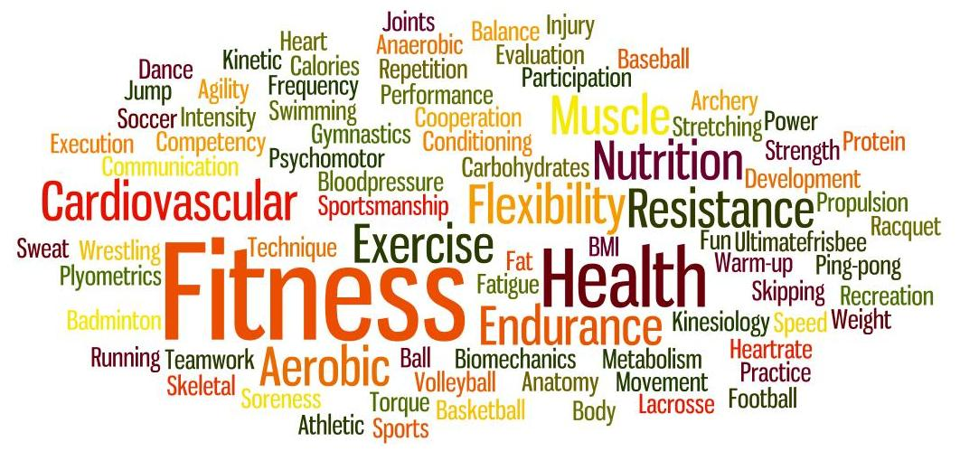
English Language

Exam Details | Paper 1: Explorations in Reading & Writing 1 hour 45 minutes  Section A: Reading (one literature fiction text) 25%  1 short form question (1 x 4 marks)  - 2 longer form questions (2 x 8 marks)  - 1 extended question (1 x 20 marks)  Section B: Writing (descriptive or narrative writing) 25%  - 1 extended writing question (24 marks for content, 16 marks for technical accuracy)  Paper 2: Writers’ Viewpoints and Perspectives  1 hour 45 minutes  Section A: Reading (one non-fiction text and one literary non-fiction text) 25%  - 1 short form question (1 x 4 marks)  - 2 longer form questions (1 x 8, 1 x 12 marks)  - 1 extended question (1 x 16 marks)  Section B: Writing (writing to present a viewpoint) 25%  - 1 extended writing question (24 marks for content, 16 marks for technical accuracy)  All students examined at the end of Year 11
Other Assessment | Non-Examination Assessment: Spoken Language  - Presenting  - Responding to questions and feedback  - Use of Standard English  This is a teacher assessed unit which carries no marks towards a GCSE qualification.
Revision Guidance | CGP Revision Guides  www.BBCBitesize.co.uk
What can I do? | Encourage wide reading across non-fiction and fiction texts  Ensure that your daughter makes the most of revision sessions and mock examination experience.
Useful Websites | School VLE PLC page
ADVICE FOR STUDENTS:  What can I do to succeed in this subject? | Attend revision sessions; make the most of mock examinations; read widely across fiction and non-fiction to improve your vocabulary and your confidence in responding to unfamiliar reading passages
What can I do to excel in this subject? | Analyse and evaluate the effect of language choices in longer answer questions in Section A of the exams. Plan carefully before writing your responses and leave enough time to check your work in Section B of the exams.

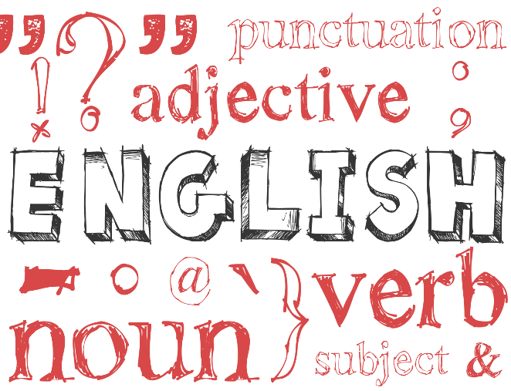

English Literature
Exam Details | Paper 1: Shakespeare & the Nineteenth Century Novel  - 1 hour 45 minutes  - 64 marks  - 40% of GCSE  - closed book  Section A Shakespeare: students will answer one question on their play. They will be required to write in detail about an extract from the play and then to write about the play as a whole.  Section B The 19th-Century Novel: students will answer one question on a novel they have studied. They will be required to write in detail about an extract of this novel and the novel as a whole.  Paper 2: Modern Texts and Poetry  - 2 hour 15 minutes  - 96 marks  - 60% of GCSE  - closed book  - Section A Modern texts: students will answer one essay question from a choice of two on a modern text they have studied.  - Section B Poetry: students will answer one comparative question on one named poem printed on the paper and one other poem from their anthology cluster.  - Section C Unseen poetry: Students will answer one question on one  unseen poem and one question comparing this poem with a second unseen poem.  All students examined at the end of Year 11
Revision Guidance | CGP Revision Guides  www.BBCBitesize.co.uk  http://www.shmoop.com  http://www.sparknotes.com  https://www.memrise.com/  York Notes Revision Guides
What can I do? | Encourage your daughter to re-read her Literature texts during the holidays, to memorise a range of quotations for use in her exams and to attend revision sessions.
Useful Websites | School VLE PLC page
ADVICE FOR STUDENTS:  What can I do to succeed in this subject? | Re-read your literature texts during the holidays, memorise a range of quotations, practise planning essay responses and attend revision sessions.
What can I do to excel in this subject? | Analyse and evaluate the effect of form, structure and language and embed short, precise quotations as evidence in essay responses. Draw perceptive and sharply relevant links between social, historical and literary context and the texts that you have studied. Ensure that you know your literature texts in meticulous detail.

Maths
Exam Detail | All students:  Edexcel LINEAR - Specification A  GCSE Maths is assessed by a terminal exam paper  (2 papers) at the end of Y11, one non-calculator and one calculator exam.  Sets 1- 6 will sit the higher tier  Sets 7- 9 will sit the foundation tier  Edexcel Level Awards  Set 7 will sit the Number Measure (level 2) and the Statistical Methods (level 1).  Set 8 will sit the Statistical Methods (level 1).  Set 9 will sit the Number Measure (level 1) and the Statistical Methods (level 1).  Further Mathematics GCSE (AQA)  Set 1&2 will sit the Further Mathematics GCSE
Revision Guidance | Revision workbooks and guides will be available for the students to buy.  Students can use  www.mymathsco.uk – especially the Booster packs which target specific grades samlearning GCSE bitesize  Nearer the exams there will be additional practice papers and other resources on the maths area of the VLE
What can I do? | Ensure the revision books are purchased.  Make sure your daughter has correct equipment, such as a black ink pen, calculator, ruler, compass and protractor.
Useful Websites | School VLE PLC page.
ADVICE FOR STUDENTS:  What can I do to succeed in this subject? | Make sure that you are completing the past papers that are set for you.  Seek help with the topics that you find difficult
What can I do to excel in this subject? | Revisit past papers that you have already completed and attempt the topics that you were unable to do

The majority of year 11 students will complete Additional Science exams in year 11. | Additional Science is composed of four ‘elements’ each accounting for 25% of the final grade:  Biology (higher or foundation paper) 1 hour 10 June 2016  Chemistry (higher or foundation paper) 1 hour 15 June 2016 Physics (higher or foundation paper) 1 hour 17 June 2016 Practical exam (ISA): this is completed in October.
Revision Guidance | The key resource for you to use is your revision guide, workbook, past papers and Doddle: www.doddlelearn.co.uk  Past papers which can be found by using Google and typing in “AQA  Additional Science 4408”  SAM learning and Bitesize are also useful revision resources.
What can I do? | Advice for parents  Know when your daughter’s examinations will take place.  Support her with studies by ensuring that:  She is completing all homework.  She is completing revision activities on Doddle, Bitesize, Samlearning.  She is completing past papers from the AQA Exam board site.  She is using the personalised learning check lists to identify weaker topics for revision
Additional Science

GCSE SCIENCE A
The majority of year 11 students completed Science A exams in year 10.  However, some students are taking Science A for the first time in June 2017 and a few are repeating Science A in June 2017 in order to improve their grade. | Science A is composed of four ‘elements’ each accounting for 25% of the final grade:  Biology (higher or foundation paper) 1 hour 16 May 2017  Chemistry (higher or foundation paper) 1 hour 18 May 2017  Physics (higher or foundation paper) 1 hour 24 May 2017  Practical exam (ISA) this was completed in year 10 by most students: however some students will be taking this for the first time in October; Students who are retaking their Science A exam in June 2017, will need to complete their practical exam outside the school timetable on a Saturday in the spring term of 2017 (letter to be issued).
Revision Guidance | The key resource for you to use is your revision guide, workbook, past papers and Doddle: www.doddlelearn.co.uk  Past papers which can be found by using Google and typing in “AQA Science A 4405” and/or AQA Additional Science (4408)  SAM learning and Bitesize are also useful revision resources.
What can I do? | Advice for parents  Know when your daughter’s examinations will take place.  Support her with studies by ensuring that:  She is completing all homework.  She is completing revision activities on Doddle, Bitesize, Samlearning.  She is completing past papers from the AQA Exam board site.  She is using the personalised learning check lists to identify weaker topics for revision.
ADVICE FOR STUDENTS  What can I do to succeed in this subject? | Regularly review your work to check your understanding  Start your revision early  Ask your teachers for advice  Practise and develop effective revision techniques, not just copying from a revision guide
What can I do to excel in this subject? | Read around the topics you are studying, for example, using revision guides, websites, documentaries and specialist magazines and make extra notes
Triple Science involves taking all three Sciences separately and resulting in three separate GCSEs. Your daughter will achieve a GCSE in:  Biology;  Chemistry; Physics. | Biology is composed of four ‘elements’ each accounting for 25% of the final grade:  Biology paper 1 (higher or foundation paper) 1 hour 16 May 2017  Biology paper 2 (higher or foundation paper) 1 hour 9 June 2017  Biology paper 3 (higher or foundation paper) 1 hour 9 June 2017  Biology practical exam (ISA) - This was completed during the Y10 summer term.  Chemistry is composed of four ‘elements’ each accounting for 25% of the final grade:  Chemistry paper 1 (higher or foundation paper) 1 hour 18 May 2017  Chemistry paper 2 (higher or foundation paper) 1 hour 14 June 2017  Chemistry paper 3 (higher or foundation paper) 1 hour 14 June 2017  Chemistry practical exam (ISA) this was completed during the Y10 summer term.  Physics is composed of four ‘elements’ each accounting for 25% of the final grade:  Physics paper 1 (higher or foundation paper) 1 hour 24 May 2017  Physics paper 2 (higher or foundation paper) 1 hour 16 June 2017  Physics paper 3 (higher or foundation paper) 1 hour 16 June 2017  Physics practical exam (ISA) - was completed during the Y10 summer term.  Students will be offered the opportunity to improve their ISA grades, if necessary, outside the school timetable in the Spring term
Revision Guidance | The key resource for you to use is your revision guide, past papers and Doddle: www.doddlelearn.co.uk.  Past papers, which can be found by using Google and typing in “AQA Biology 4401”, “AQA Chemistry 4402” and “AQA Physics 4403”. SAM learning and Bitesize are also useful resources.
What can I do? | Advice for parents  Know when your daughter’s examinations will take place.  Support her with studies by ensuring that:  She is completing all homework.  She is completing revision activities on Doddle, Bitesize, Sam learning.  She is completing past papers from the AQA Exam board site.  She is using the personalised learning check lists to identify weaker topics for revision.
ADVICE FOR STUDENTS:  What can I do to succeed in this subject? | Regularly review your work to check your understanding  Start your revision early  Ask your teachers for advice  Practise and develop effective revision techniques, not just copying from a revision guide
What can I do to excel in this subject? | Read around the topics you are studying, for example, using revision guides, websites, documentaries and specialist magazines and make extra notes

Triple Science

Expressive Arts Dance
Exam Detail | Completion of Unit 2 – Externally moderated performance work and portfolio – 30%  Exam to be held Late November/December 2016 date TBC  Unit 1 – Externally moderated performance work in response to set stimuli and portfolio – 40%  Exam to be held in the late Spring Term of 2017 date TBC.
Coursework Deadlines | Controlled Assessments:  Unit 2 – Written portfolio and Comparative Essay – to be completed prior to external moderation. (see above)  Unit 1 – Written portfolio and Comparative Essay to be completed prior to external moderation. (see above)
Revision Guidance | Ensure all after school rehearsals and lessons are attended. Attendance in school is vital for rehearsals and the support of your groups in performances – Weekly Wednesday after school rehearsals.  Ensure all research is completed and all dramatic and dance work is rehearsed and committed to memory.
What can I do? | Ensure all written coursework is undertaken at home.  Ensure attendance at rehearsals and on Controlled Assessment and performance days.  Encourage your daughter to explore the Art works via the internet.  If possible try to visit a live show to gain experience of the theatre.
Useful Websites | Youtube.com  School VLE  www.akramkhan.net
ADVICE FOR STUDENTS:  What can I do to succeed in this subject? | Ensure all rehearsals and lessons are attended.  Ensure all written tasks are thoroughly researched and completed to the best of her ability.  Meet all deadlines for homework and coursework  A positive, co-operative and open minded attitude will enable her to explore the diverse areas of study and develop your creative and artistic responses.
What can I do to excel in this subject? | Independent research, reading and exploration to ensure that choreographic ideas are original, creative and demonstrating depth of thought and understanding.  Excellent performers have a keen understanding of the subject area and are keen to know about and see the work of current influential choreographers, performers and artists.  Gain as much performance experience as possible.

Hospitality

What will I study? | Concentrates on the hospitality aspect of the hospitality and catering industry, in particular the skills related to the preparation and carrying out an event. Areas they study are The Industry, types of service, job roles, menu planning, planning for functions and events, customer care, communication and teamwork, environmental considerations.
Exam Details | Event based task 60% of overall grade(internally assessed)  Written paper (1 ¼ hours) 40% overall grade
Revision Guidance | Much of the course, is coursework, and as this makes up a large part of the mark it is really important that students work hard on keeping to deadlines in writing it up and completing it to their best of their ability.  Revision for written exam – book can be brought called Hospitality and Catering – my revision notes published by Hodder Education.
Useful Websites I can refer to: | www.bbcgoodfood.com  Allrecipes.com  Jamie Oliver.com  Realfood.tesco.com
What can I do? | Ensure students keep practicing dishes at home. All catering students should have practical lessons most weeks, so students need to be organised with ingredients and containers to take it home in. When it comes to the actual event they need to make sure they have ingredients for trialling dishes, and help with researching appropriate dishes, so they have the confidence to challenge themselves with higher level practical skills.
What does your daughter need to do to succeed in this subject? | Be organised with ingredients and planning  Keep up with coursework  Listen to teachers’ advice on recipe choices and improvements in coursework.
What does your daughter need to excel in this subject? | Use high level cooking and presentation skills  A big team player in event and event planning.  Coursework done to a good standard, showing thorough research and good presentation.
