Art and Design GCSE
Exam Detail | There will be a full mock exam in preparation for the GCSE and work completed over the two day exam will form part of the 60% course work unit.  The exam title (40%) will be issued around Easter time and students have approx. 6 weeks to prepare for the exam. The approach is very similar to coursework and a final piece/s will be produced over two days under controlled conditions.
Coursework Deadlines | One unit of coursework over two sketch books and covering two different titles. Completion of all coursework by hand in date after exam which is usually in April (date to be confirmed).  Students will be expected to come in and put up an exhibition of their work usually early June for the external moderator to mark the work.
Revision Guidance | Targeted sessions for catch up and coursework guidance are on Monday and Wednesday after school in the Art Department. Students are welcome to work after school independently in the department after school.
What can I do? | Help with ideas from the words given, aid with research tasks.  Maybe visit a gallery or exhibition.  Ensure your daughter has all the equipment she needs.  A quiet space to do Art work preparation.  Encourage her to stay after school for extra art.
Useful Websites | www.nationalgallery.co.uk  www.art2day.co.uk  www.studentartguide.com  www.tate.org.uk
What does your daughter need to do to succeed in this subject? | Keep up to date with all the work that your teacher sets. Be independent in your working practice and use research of other artists to inform your own ideas.
What does your daughter need to excel in this subject? | You need to put in the time to ensure that your ideas are well explored and researched. Use your teacher’s expertise and do not be afraid to ask for help and advice.

GCSE Business Studies

What will I study? | Students are studying the AQA specification  All students will study the three core units which are:  Unit 1 Setting up a business  Unit 2 Growing as a business  Unit 3 Investigating Business
How will I be assessed? | Over the three units, your will have two papers worth 40% and 35% and a Controlled Assessment – Unit 3 worth 25%. This will enable you to gain a GCSE in Business Studies.
Assessments | Units 1 and 2 will be taught in years 1 and year 2 respectively.  Unit 3 – the Controlled Assessment will be completed in year 10 in order to enable your child to gain maximum revision time in the final year.  The exam board requirements is usually for students to research one or more aspects of a small local business and make recommendations to improve business performance. This provides students with an opportunity to display a range of skills such as research, analysis, evaluation as well as helping to develop communication skills.
Subject support? | Staff available at lunchtime or break times to provide additional student support.  Revision sessions takes place throughout the year leading up to assessment points and the final exams.
Revision Guidance | Department revision pack.  CGP GCSE Business Studies revision and practice book.  Exam past papers.
Useful Websites I can refer to: | www.tutor2u.net  http://www.bbc.co.uk/education/subjects/zpsvr82  http://www.beebusinessbee.co.uk/index.php/pages/223-beebusinessbee-for-business-students  http://www.aqa.org.uk/subjects/business-subjects/gcse/business
What can I do? | Help your daughter to remember information from the lessons by going over classwork with her.  Make sure your daughter completes work by the set deadlines.  Ensure both teachers and parents communicate challenges which may prevent students from performing well  .
What does your daughter need to do to succeed in this subject? | Students must ensure that they attend all lessons and support sessions.  Students should ensure all class and homework tasks are completed to the best of their ability.  Students must review and revise their class notes throughout the duration of the course. This is of particular importance now that all GCSE exams have moved to the linear assessment model.
What does your daughter need to excel in this subject? | All students should spend two hours each week on homework tasks and review and consolidation activities, in order to achieve well within this subject.

Child Development

What will I study? | BTEC/Pearson  Exam : Summer – end of Year 10  Resit Exam – January Year 11  Exam Unit – worth 25 % of overall qualification  Topic covered in exam  Patterns of Child Development
Other Assessment | Coursework Units 2 & 3  Promoting Children’s Development through Play  The Principles of Early Years Practice  Coursework Units – worth 75 % of overall qualification
Subject Support | Staff available at lunch time and after school
Revision Guidance | Revision Resources on School VLE  Staff available to speak to students at break times, lunch times and after school  After school coursework catch up and revision time – Weekly Mondays 3.10pm to 4pm
What can I do? | Ensure coursework is up to date and all hand in dates are met.
Useful Websites/Text Books | Penny Tassioni – Children’s Play Learning and Development BTEC First ISBN 878 1 447944 61 4  http://www.nurseryworld.co.uk/
What does your daughter need to do to succeed in this subject? | Meet all coursework hand in deadlines to ensure the higher grading criteria can be met. Complete practice papers for the exam
What does your daughter need to excel in this subject? | Complete all tasks to Distinction level
Computer Science
Exam Detail | The new specification is split into three components:  Component 01 – Computer Systems - This focuses on Computer Systems. It is an examined unit and makes up 40% of the assessment total.  Component 02 – Computational Thinking, Algorithms and Programming. - This is a new written exam, focused on computational thinking and algorithms. Students will be tested on the elements of computational thinking and logic. They are principally assessed as to their ability to write, correct and improve algorithms. This makes up 40% of the assessment total.
Coursework Deadlines | Component 03 – Programming Project (non-exam and controlled assessment )  This component is the non-exam assessment where candidates will be challenged by a range of exciting and engaging tasks to apply the knowledge and skills they have learned.  February 2018
Revision Guidance | Theory  VLE > Departments>computing> Ks4> computer science  PLCs  www.ocr.org.uk/computing  Sam Learning  Completed worksheets and homework sheets  Theory E-book  Programming techniques  Download python 3 (Its Free) and use tutorial provided
What can I do? | Ensure your daughter knows the deadlines for the course.
Useful Websites | School VLE  www.teach ICT.com  www.ocr.org.uk/computing  www.code.org  www.codecademy.com  Sam Learning
What does your daughter need to do to succeed in this subject? | Use and review their PLCs to plan revision carefully. Allow time to cover all the content. Do as many past paper questions as possible to help improve exam technique.
What does your daughter need to excel in this subject? | For coursework Assessments: Ensure all work is given in on time  For the Written exam: Ensure attendance at revision sessions. Constantly recap key terminology. Find real life examples to help remember theory topics.

GCSE Dance
What will I study? | Performance and Choreography - You will study and perform a wide range of dance styles and understand in detail the demands of performance and the necessary skills required. You will also develop your skills, knowledge and understanding of the choreographic process.  Dance appreciation - You will study six professional dance works in their entirety and will be required to describe, analyse, interpret, evaluate and reflect on the works in response to short answer and extended writing questions. You will also be required to employ your knowledge and understanding of choreographic processes and performing skills via critical appreciation of your own work.
How will I be assessed? | Component 1: Performance and Choreography – 60% of GCSE  Internally marked and externally moderated  Performance – 30% of GCSE  - Set phrases through a solo performance  - Duet/trio performance  Choreography – 30% of GCSE  - Solo or group choreography  Component 2: Dance Appreciation – 40% of GCSE  - 40% of GCSE  - Written exam: 1 hour 30 minutes, 80 marks  Exam takes place at the end of Year 11
Assessments | Solo performance and Duet/trio to take place in either Summer Term 2017 or Autumn Term 2017. Date TBC  Solo or group choreography to take place in Spring Term 2018 date TBC  Written Exam – end of Year 11 2018  Various internal assessments will take place throughout the course.
Subject support? | Staff are available during lunchtimes for additional support.
Revision Guidance | Ensure all after school rehearsals and lessons are attended. Students are welcome to work independently in the department after school on Fridays and Wednesdays. Attend Revision sessions
Useful Websites I can refer to: | stopgapdance.com/productions/artificial-things-2014-stage  https://www.trinitylaban.ac.uk
What can I do? | Ensure all written homework tasks are completed. Ensure attendance at all after school rehearsals and on assessment and performance days. Encourage your daughter to explore the six set works via the Internet. .If possible try to visit a live performance to gain experience of the theatre.  Encourage your daughter to participate in extra curricular activities, such as Dance Club, which will help develop performance skills and broaden her experience in preparation for her examination.
What does your daughter need to do to succeed in this subject? | Ensure all rehearsals and lessons are attended. Attendance in school is vital for rehearsals and the support of their groups in performances. Ensure all written tasks are thoroughly researched and completed to the best of her ability. A positive, co-operative and open-minded attitude will enable her to explore the diverse areas of study and develop her creative and artistic responses.
What does your daughter need to excel in this subject? | Independent research, reading and exploration to ensure that choreographic ideas are original, creative and demonstrating depth of thought and understanding. Excellent performers have a keen understanding of the subject area and are keen to know about and see the work of current influential choreographers, performers and artists.

GCSE Design and Technology

What will I study? | Students will undertake two practice projects in Year 10 as preparation for the controlled assessment, which starts in the summer term of Year 10. They will also complete theory lessons preparing them for the final exam.  In Year 11 students complete the controlled assessment and revision for the final exam.
Exam Details | The examination body is AQA.  Qualification is Product design 4555.  Students will sit a 2 hour exam at the end of Year 11 which will account for 40% of their final grade.  The exam tests designing skills based on a pre-release theme and knowledge and understanding of key design issues.  There will be an end of Year 10 exam and mocks in January of Year 11.
Other Assessment | Controlled Assessment is 60% of the final grade started at the end of Year 10 and completed by Easter of Year 11.  Topics are chosen by the student and based on a list given by AQA.  Interim deadlines are set throughout Year 11 and are published in September of Year11.
Revision Guidance | Nelson Thornes AQA Product design – issued by school  May also want to get Lonsdale Product design revision guide.  Controlled assessment clinic Year 10 and 11 Tuesday after school.  After school sessions by class teachers in Year 10 as needed usually during making sessions.
Useful Websites I can refer to: | www.technologystudent.com  GCSE Bitesize
What can I do? | Support when students need to find or organise materials for practical sessions.  Support with advice and evaluation as a third party during designing, modelling, making and final evaluation work.  Students are expected to understand consumer views.
What does your daughter need to do to succeed in this subject? | Ask whenever they are unsure. Manage an extended design and make project with independence. Practice past questions when revising.
What does your daughter need to excel in this subject? | Be creative, determined and resourceful.  Be prepared to use their own time to develop their work.

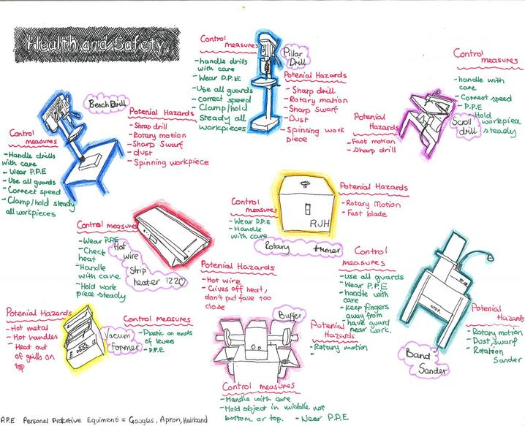

GCSE Drama

What will I study? | The subject content for GCSE Drama is divided into three components:  Understanding drama  Devising drama  Texts in practice
Exam Details | AQA GCSE Drama (8261)  Understanding drama  Knowledge and understanding of drama and theatre, Study of one set play from a choice of six, Analysis and evaluation of the work of live theatre makers  Written exam: 1 hour and 45 minutes, Open book 40% of GCSE  Questions  Section A: multiple choice  Section B: four questions on a given extract from the set play  Chosen  Section C: one question (from a choice) on the work of theatre  makers in a single live theatre production
Other Assessment | Controlled Assessment  Devising Drama  Students create and perform devised drama (as performer or designer). They analyse and evaluate their own work with the creation and development of a devising log. Teacher assessed, filmed and moderated by AQA Examiner. Devising log, Devised performance 40% of GCSE  Texts in practice: Practical  Performance of two extracts from one play (students may contribute as performer or designer) Free choice of play but it must contrast with the set play chosen for Component 1.  Performance of Extract 1 and Extract 2 marked by AQA Visiting Examiner 20% of GCSE
Revision Guidance | Students will need to ensure they are entirely familiar with the set texts and have seen and studied at least one live production throughout the course. Students may be required to attend additional rehearsals outside of lesson times. They should keep regular records of each lesson in their Drama notebooks to assist them with creating their Devising Logs.
Useful Websites I can refer to: | BBC Bitesize: http://www.bbc.co.uk/education/subjects/zbckjxs  Theatre careers: https://ccskills.org.uk/careers/advice/any/theatre  Plays and playwrights: http://www.doollee.com
What can I do? | Ensure your daughter knows when her additional rehearsals are and practices any lines. Ensure she attends all practical exams and live performances and show your support by attending any public performances. Look through her drama notebook regularly to check she has completed records accurately of the lessons.
What does your daughter need to do to succeed in this subject? | Maintain a positive attitude and an inquisitive mind. Be willing to work with others effectively and experiment with different theatrical forms and techniques.
What does your daughter need to excel in this subject? | Visit a range of live theatre productions regularly. Conduct wider reading of theatre practitioners and styles, and read professional theatre reviews.

GCSE English Language
What will I study? | Explorations in Reading and Writing  Writers’ Viewpoints and Perspectives.
Exam Details | English Language GCSE (AQA)  Paper 1: Explorations in Reading and Writing 1 hour 45 minutes  Section A: Reading (one literature fiction text) 25%  - 1 short form question (1 x 4 marks)  - 2 longer form questions (2 x 8 marks)  - 1 extended question (1 x 20 marks)  Section B: Writing (descriptive or narrative writing) 25%  - 1 extended writing question (24 marks for content, 16 marks for technical accuracy)  Paper 2: Writers’ Viewpoints and Perspectives 1 hour 45 minutes  Section A: Reading (one non-fiction text and one literary non-fiction text) 25%  - 1 short form question (1 x 4 marks)  - 2 longer form questions (1 x 8, 1 x 12 marks)  - 1 extended question (1 x 16 marks)  Section B: Writing (writing to present a viewpoint) 25%  - 1 extended writing question (24 marks for content, 16 marks for technical accuracy)  All students examined at the end of Year 11
Other Assessments | Non-Examination Assessment: Spoken Language  - Presenting  - Responding to questions and feedback  - Use of Standard English  This is a teacher assessed unit which carries no marks towards a GCSE qualification.
Revision Guidance | School VLE PLC page
Useful Websites I can refer to: | CGP Revision Guides  SAM Learning  www.BBCBitesize.co.uk
What can I do? | Encourage wide reading across non-fiction and fiction texts. Ensure that your daughter makes the most of revision sessions and mock examination experience.
What does your daughter need to do to succeed in this subject? | Attend revision sessions; make the most of mock examinations; read widely across fiction and non-fiction to improve your vocabulary and your confidence in responding to unfamiliar reading passages.
What does your daughter need to excel in this subject? | Analyse and evaluate the effect of language choices in longer answer questions in Section A of the exams. Plan carefully before writing your responses and leave enough time to check your work in Section B of the exams.

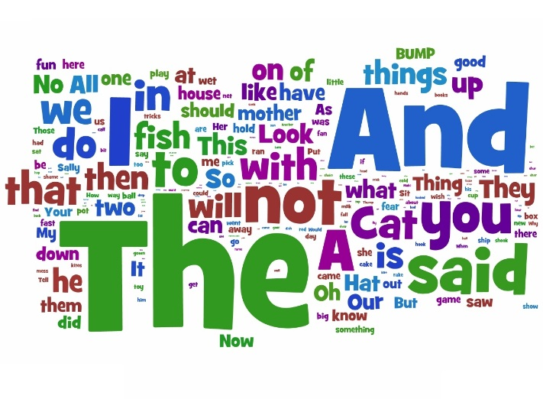
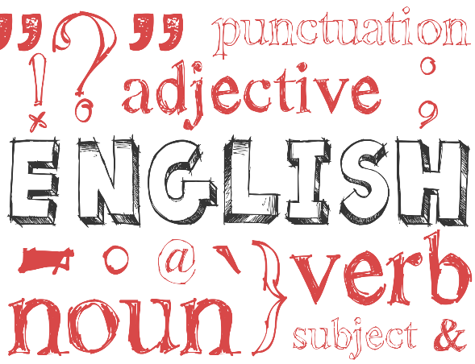

GCSE English Literature
What will I study? | Shakespeare and the Nineteenth Century Novel  Modern texts and Poetry
Exam Details | English Literature GCSE (AQA)  Paper 1: Shakespeare & the Nineteenth Century Novel  - 1 hour 45 minutes  - 64 marks  - 40% of GCSE  - closed book  Section A Shakespeare: students will answer one question on their play. They will be required to write in detail about an extract from the play and then to write about the play as a whole.  Section B The 19th-century novel: students will answer one question on a novel they have studied. They will be required to write in detail about an extract from this novel and then to write about the novel as a whole.  Paper 2: Modern texts and Poetry  - 2 hour 15 minutes  - 96 marks  - 60% of GCSE  - closed book  Section A Modern texts: students will answer one essay question from a choice of two on a modern text they have studied.  Section B Poetry: students will answer one comparative question on one named poem printed on the paper and one other poem from their anthology cluster.  Section C Unseen poetry: Students will answer one question on one  unseen poem and one question comparing this poem with a second unseen poem.  All students examined at the end of Year 11
Revision Guidance | School VLE PLC page  York Notes Revision Guides  CGP Revision Guides
Useful Websites I can refer to: | SAM Learning  www.BBCBitesize.co.uk  http://www.shmoop.com/  http://www.sparknotes.com
What can I do? | Encourage wide reading across non-fiction and fiction texts. Ensure that your daughter makes the most of revision sessions and mock examination experience.
What does your daughter need to do to succeed in this subject? | Re-read your literature texts during the holidays, memorise a range of quotations, practise planning essay responses, attend revision sessions.
What does your daughter need to excel in this subject? | Analyse and evaluate the effect of form, structure and language and embed short, precise quotations as evidence in essay responses. Draw perceptive and sharply relevant links between social, historical and literary context and the texts that you have studied. Ensure that you know your literature texts in meticulous detail.

What will I study? | EDEXCEL GCSE Geography B
Exam Details | Exam 1: Global Geographical Issues - Topic 1: Hazardous Earth, Topic 2: Development dynamics, Topic 3: Challenges of an urbanising world (37.5% of GCSE, 94 marks, 1 hour 30 minutes)  Exam 2: UK Geographical issues - Topic 4: The UK’s evolving physical landscape, 4a Subtopic: Coasts (Linked to topic 6), 4b Subtopic: River processes and pressures, Topic 5: The UK’s evolving human landscape, Topic 6: Geographical Investigations (37.5% of GCSE, 94 marks, 1 hour 30 minutes)  Exam 3: People and environmental Issues (Making geographical decisions) Topic 7: People and the biosphere, Topic 8: Forests under threat, Topic 9: Consuming energy resources (25% of GCSE, 64 marks, 1 hour 30 mins)
Other Assessment | Mock exams during the summer term in year 10 and the Autumn/spring term of year 11. Small topic tests at the end of each term/half term. You will be asked to redo individual questions or the whole test if you have not achieved a high enough grade in relation to your target.
Revision Guidance | Revision resources, including exam questions on the VLE for you to use for end of topic tests.  Be careful when buying revision guides, make sure they are for the new 1-9 GCSE specification EDEXCEL B.  Go through your PLC and make flash cards or posters using your folder.  You should also test yourself on key words!  Don’t just read through your folder, this isn’t very effective!
What can I do? | Encourage your daughter to complete homework and revision.  Help to test her verbally on key words and concepts.  Help to keep her folder organised  Buy a revision guide  Encourage her to take an interest in current geographical events.
Useful Websites | EDEXCEL GCSE Geography B – Exam board website.
What does your daughter need to do to succeed in this subject? | Complete all work on time and to the best of her ability. Catch up missed work. Make neat notes and keep them in good order. It will make them easier to revise from. Act on teacher feedback. Keep track of progress on the tracking sheet. Ask a Geography teacher for help if something isn’t clear.
What does your daughter need to excel in this subject? | Top geographers keep an eye on the world around them. They know about current global issues and develop opinions on them. In their exam answers they fully explain their points, use detailed examples and express their opinions.
GCSE Geography

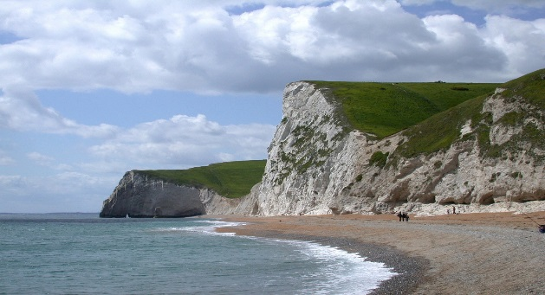

Health and Social Care

Exam Details | BTEC/Pearson  Exam : Summer – end of Year 10  Resit Exam – January Year 11  Exam Unit – worth 25 % of overall qualification  Topic covered in exam  Human Lifespan Development
Other Assessment | Coursework Units 2, 5 & 7  Health & Social Care Values  Promoting Health & Well Being  Equality & Diversity in Health & Social Care  Coursework Units – worth 75 % of overall qualification
Revision Guidance | Revise BTEC – BTEC First Revision Guide - Pearson  Revise BTEC – BTEC First Revision Workbook - Pearson  Staff available to speak to students at break times, lunch times and after school  After school coursework catch up and revision time – Weekly Mondays 3.10pm to 4pm
What can I do? | Ensure coursework is up to date and all hand in dates are met.
Useful Websites/Text Books | BTEC First Health & Social Care – Pearson  http://www.bbc.com/news/us/health
What does your daughter need to do to succeed in this subject? | Meet all coursework submission deadlines to ensure the higher grading criteria can be met. Complete practice papers for the exam
What does your daughter need to excel in this subject? | Complete all tasks to Distinction level

GCSE History
What will I study? | Thematic study and historic environment - Medicine in Britain, c1250–present  The British sector of the Western Front, 1914–18: injuries, treatment and the trenches  Period Study and British Depth Study - The American West, c1835–c1895 and Early Elizabethan England  Modern Depth Study - Weimar and Nazi Germany, 1918–39
Exam Details | Examination body is Edexcel and the examinations will be in June 2017.  PAPER 1: Thematic study and historic environment (1 hour 15 min, 30%)  PAPER 2: Period Study and British Depth Study (1 hour 45 min, 40%)  PAPER 3: Modern Depth Study (1 hour 20 min, 30%)
Subject support? | Students will complete past paper questions throughout the course.  Students can speak to the History staff at any break time or before school.
Revision Guidance | Any revision books on these topics can be used, there should be new ones to fit with this specification.  There are currently some revision resources on the VLE. These will be updated as we head towards the exams.
Useful Websites I can refer to: | www.bbcbitezise.co.uk  There are also links on the History page of the student VLE.
What can I do? | Ensure your daughter knows when her exams are.  Encourage your daughter to spend some time reviewing her notes or reading around the subject when she does not have specific homework to do. There is a reading list on the VLE and on Show My Homework to help with this.
What does your daughter need to do to succeed in this subject? | Very good literacy skills and good memory recall.  An interest in the subject and a hard working attitude in lessons.
What does your daughter need to excel in this subject? | High level literacy skills and an excellent memory recall.  An interest in the subject both inside and outside of school, extra reading and attendance at History Society on Tuesdays at lunchtime in L8.

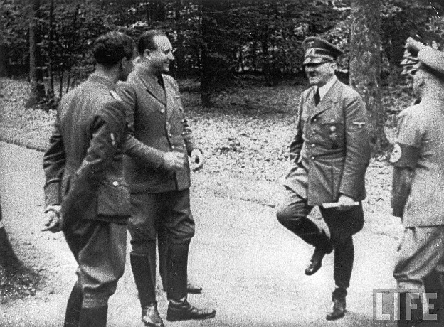

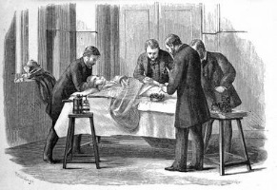

GCSE Hospitality

What will I study? | Concentrates on the hospitality aspect of the hospitality and catering industry, in particular the skills related to the preparation and carrying out an event. Areas they study are The Industry, types of service, job roles, menu planning, planning for functions and events, customer care, communication and teamwork, environmental considerations.
Exam Details | Event based task 60% of overall grade(internally assessed)  Written paper (1 ¼ hours) 40% overall grade
Revision Guidance | Much of the course, is coursework, and as this makes up a large part of the mark it is really important that students work hard on keeping to deadlines in writing it up and completing it to their best of their ability.  Revision for written exam – book can be brought called Hospitality and Catering – my revision notes published by Hodder Education.
Useful Websites I can refer to: | www.bbcgoodfood.com  Allrecipes.com  Jamie Oliver.com  Realfood.tesco.com
What can I do? | Ensure students keep practicing dishes at home. All catering students should have practical lessons most weeks, so students need to be organised with ingredients and containers to take it home in. When it comes to the actual event they need to make sure they have ingredients for trialling dishes, and help with researching appropriate dishes, so they have the confidence to challenge themselves with higher level practical skills.
What does your daughter need to do to succeed in this subject? | Be organised with ingredients and planning  Keep up with coursework  Listen to teachers’ advice on recipe choices and improvements in coursework.
What does your daughter need to excel in this subject? | Use high level cooking and presentation skills  A big team player in event and event planning.  Coursework done to a good standard, showing thorough research and good presentation.

GCSE Languages
What will I study? | Paper 1: Listening. Both tiers:  - Section A – questions in English, to be answered in English or non-verbally.  - Section B – questions in TL, to be answered in TL or non-verbally.  Paper 2: Speaking. Both tiers:  - Role-play  - Photo card  - General conversation  Paper 3: Reading. Both tiers:  - Section A – questions in English, to be answered in English or non-verbally  - Section B – questions in TL, to be answered in TL or non-verbally  - Section C – translation from TL into English  Paper 4: Writing.  Foundation Tier  - Question 1 – message (student produces four sentences in response to a photo)  - Question 2 – short passage (  - Question 3 – translation from English into TL  - Question 4 – structured writing task  Higher Tier  - Question 1 – structured writing task  - Question 2 – open-ended writing task  - Question 3 – translation from English into TL
Exam Details | Examination board: AQA.  Listening, reading, speaking and writing final exams will take place in May / June 2017
Subject support? | All staff in the department are available to speak to students before school, at break time, lunchtime and after school.
Revision Guidance | Revision sessions are held closer to the exams at lunchtimes and after school.
Useful Websites I can refer to: | Students are encouraged to use revision websites such as Linguascope, BBC Bitesize and SAMLearning
What can I do? | Encourage your daughter to revise vocabulary and grammar structures regularly
What does your daughter need to do to succeed in this subject? | Ensure that all assessed work meets their target grade.  Learn all vocabulary on a regular basis
What does your daughter need to excel in this subject? | Practice grammar and translation regularly.  Read independently at home in the target language

GCSE Maths

Exam Details | All students:  Edexcel LINEAR - Specification A  GCSE Maths is assessed by a terminal exam  (3 papers) at the end of Y11, one non-calculator and two calculator exams.  Sets 1- 6 are studying for the higher tier. A final decision about the tier of entry will be made after the mock exams  Sets 7- 9 will sit the foundation tier  Edexcel Level Awards  Set 9 will sit the Number Measure (level 1)  Further Mathematics GCSE (AQA)  Set 1&2 will sit the Further Mathematics GCSE
Revision Guidance | Revision workbooks and guides will be available for the students to buy.  Students can use www.mymaths.co.uk – especially the Booster packs which target specific grades,  Mathswatchvle  Nearer the exams there will be additional practice papers and other resources on the maths area of the VLE
Useful Websites I can refer to: | The maths area of the school VLE
What can I do? | Ensure the revision books are purchased. Make sure your daughter has correct equipment, such as a black ink pen, calculator, ruler, compasses and protractor.
What does your daughter need to do to succeed in this subject? | Complete the past papers that are set for you.  Seek help with the topics that you find difficult
What does your daughter need to excel in this subject? | Revisit the past papers that you have already completed and attempt the topics that you were unable to do

GCSE Media
What will I study? | One exam which is sat in Y11 (June 2018). The topic changes yearly and will be released in due course.
Exam Details | All Controlled Assessments are completed in Y10; Y11 is focused solely on the exam topic.  Assignment 1: magazines/ soap operas  Analysis of 2 soap opera magazine covers  Design and produce own magazine cover  Assignment 2: film promotion  Analyse how 1 film is promoted across a range of media platforms (TV/ radio/ print/ online/ digital media)  Assignment 3: MUSIC PROMOTION  Research and analysis of existing music video  Plan and produce own music video  Evaluation of own work
Subject support? | No one textbook is recommended, although there are a lot of guides and resources that give excellent definitions of key concepts.  There are also a huge amount of additional literature and learning resources on the Media VLE pages.  www.Mediaknowall.com  www.theguardian.com  AQA GCSE Student Book  GCSE Media Revision Guide, CGP Books
Revision Guidance | Encourage students to regularly use ley concepts of Language, Audience, Representation and Institution to investigate this genre.
Useful Websites I can refer to: | www.Mediaknowall.com  www.theguardian.com
What can I do? | Thoroughly understand and apply the key concepts (media language, representation, audience, institution) and respond quickly to a media brief with her prepared response. Keep on top of deadlines and be prepared to go ‘the extra distance’ when creating media products.
What does your daughter need to do to succeed in this subject? | Think through coursework briefs creatively and imaginatively reaching near professional responses in production work.
What does your daughter need to excel in this subject? | Prepare for every scenario in the exam understanding the full range of questions that could be asked and knowing how to respond in each eventuality. Understanding more complex media theories will help enhance marks further.

GCSE Music

What will I study? | The subject content for GCSE Music is divided into three components:  - Performance (Solo & Ensemble)  - Composition (One free the other set to a brief)  - Listening and Appraising  Areas of study: Instrumental Music, Vocal Music, Music for Stage and Screen, Fusions
Exam Details | Edexcel (Pearson) GCSE Music (1MU0/03)  Listening and Appraising - Written exam: 1 hour and 45 minutes, 40% of GCSE,  Questions - The paper is made up of two sections.  Section A: Areas of study, dictation and unfamiliar pieces (68 marks)  - Six questions related to six of the eight set works  - One short melody/rhythm completion exercise  - One question on an unfamiliar piece (skeleton score provided) with questions on its musical elements  Section B: Extended response comparison between a set work and one unfamiliar piece (12 marks)  - One question that asks students to compare and/or evaluate the musical elements, musical contexts and musical language of one set work with one unfamiliar piece of music.
Other Assessment | Controlled Assessments (Internally marked, externally moderated)  Performance 30% (60 marks)  - Two performances: Combined duration of four minutes  - Solo (30 marks) and Ensemble (30 marks)  Composition 30% (60 marks)  - Two compositions: Combined duration of three minutes  - One free composition (30 marks) and One set to a brief, provided by the exam board (30 marks)
Subject support? | Peripatetic instrumental lessons are provided by the school to ensure your daughters development on their first study instrument. There will be a composers’ lab offered after school for those who wish to gain more experiencing composing and using Sibelius.
Revision Guidance | Listening and Appraising - Students will need to ensure they are entirely familiar with all eight set works and that their theoretical knowledge is of a standard whereby they are able to analyse written music. Also, a competent aural ability will need to be developed in order to be able to appraise music based purely on its sonic components.  Performing - Your daughter, along with their peripatetic instrument tutor, will keep a log of the progress made in performance. They will be required to practice most days at home to ensure their continued development.  Composing - Students will be required to have a working knowledge of Sibelius as this is the software they will use to notate their compositions.
Useful Websites I can refer to: | BBC Bitesize:  http://www.bbc.co.uk/education/subjects/zpf3cdm  http://www.musictheory.net/  http://qualifications.pearson.com/en/qualifications/edexcel-gcses/music-2016.html
What can I do? | Ensure your daughter attends her instrumental lessons and completes all homework assignments. Encourage them to take part in extra circular music activities like orchestra and concerts.
What does your daughter need to do to succeed in this subject? | Maintain a positive attitude and an inquisitive mind. Be willing to work hard on theoretical practices as well as the practical elements of the course. Listen to a wide variety to musical styles and build a familiarity with music from all genres and eras. Feel comfortable experimenting in musical areas that they may have little or no previous knowledge of.
What does your daughter need to excel in this subject? | Use the facilities at school in and out of lessons to gain as much exposure to the compositional element as they can. Spend time researching all music styles to help them understand the elements of those covered by the syllabus from all the areas of study. Habitual and regimented instrument practice. Also, taking part in musical activities and ensemble as well as those which are offered at school (Gigs, concerts, youth music programs).
GCSE PE

What will I study? | The human body and movement in physical activity and sport  Socio-cultural influences and well-being in physical activity and sport  Practical performance in physical activity and sport
Exam Details | Paper 1: The human body and movement in physical activity and sport  Applied anatomy and physiology, Movement analysis, Physical training, Use of data  Written exam: 1 hour 15 minutes 30% of GCSE  Paper 2: Socio-cultural influences and well-being in physical activity and sport  Sports psychology, Socio-cultural influences, Health, fitness and well-being, Use of data  Written exam: 1 hour 15 minutes 30% of GCSE  Non-exam assessment: Practical performance in physical activity and sport  Practical performance in three different physical activities in the role of player/performer (one in  a team activity, one in an individual activity and a third in either a team or in an individual activity).  Analysis and evaluation of performance to bring about improvement in one activity.  Assessed by teachers, Moderated by AQA 40% of GCSE
Other Assessment | Controlled Assessment - To be completed in lesson time. Will be practical based throughout lessons. Theory CA will be an analysis of their own performance in a selected sporting activity.
Subject support? | Staff are available at any time during the school day and after school.  Students should be attending at least one after school club a week to keep their fitness and skill levels up and should be participating in at least one sport on a regular basis at a club outside of the school environment.
Revision Guidance | GCSE PE Bitesize.  Teachpe.com.  Mypeexam.org (school will provided students with passwords and access to this)  PE to 16 book by Sally Fountain & Linda Goodwin, by Oxford Press
Useful Websites I can refer to: | UK Sport  English Institute of Sport  Sport England  Youth Sports Trust  GCSE Bitesize  Mypeexam.org
What can I do? | Make sure that your daughter has the correct PE kit and knows which days she has PE. Revision classes will begin in Y11.
What does your daughter need to do to succeed in this subject? | Ensure she has the correct PE kit for each practical lesson.  She needs to be a regular attendee at extra-curricular clubs to aid practical performance.  She should have a keen interest in the sporting world and watch sport regularly to aid understanding of tactics and rules across a variety of sports.  Many aspects of PE involves working in teams. She will need to be willing to work with others to develop clear communication skills.
What does your daughter need to excel in this subject? | Belong to a club, training on a regular basis throughout the week in at least one sport.  Be able to analyse own and others strengths and weaknesses.  Attend revision sessions
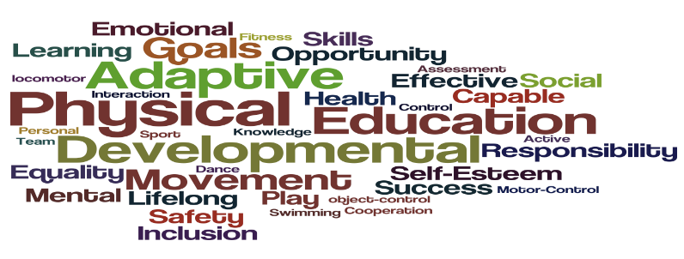

GCSE Religious Studies and Philosophy

What will I study? | Religious, philosophy and ethical studies in the modern world  Study of Christianity  Study of World Faith (Islam)
Exam Details | Pupils who’ve opted to study a full course in 3 periods per week are studying EDUQAS Route A Religious Studies. This is 100% exam (3 exam papers. 2x 1 hr and 1x 2hr). Pupils will sit examinations in the Summer 2018 session  Pupils studying core RS will also be studying the EQUQAS Route A Religious Studies spec. however, pupils will be partaking in the short course examination which looks at the same topics as the full course pupils bar the practices of both Islam and Christianity and Islam. Topics covered in the Religious, philosophy and ethical studies in the modern world paper will also be the same. However, unlike the full course pupils, short course pupils will only be looking at the topics concerning ‘Issues of Relationships’ and ‘Issues of Life and Death’. This means pupils will be assessed in Summer 2018 with 3 exam papers 2x 30 mins and 1x 1hr.
Other Assessment | 2hr exam Full Course / 1h exam Short Course  Issues of Relationships (marriage, gender equality, contraception etc.)  Issues of Life and Death (Afterlife, abortion, sanctity and quality of life, euthanasia etc.)  Issues of Good and Evil (Good and evil, freewill, punishment, suffering etc.)  Issues of Human rights (prejudice and discrimination, human rights, extremism, poverty etc.)  1hr exam Full Course / 30 mins Short Course  Beliefs and teachings (the afterlife, creation, nature of God etc.)  Practices (Worship, pilgrimage, forms of worship, Christianity in Britain etc.)  1hr exam Full Course / 30 mins Short Course  Beliefs and teachings (The nature of Allah, Angels, Prophethood, afterlife etc.)  Practices (Jihad, 5 pillars of Sunni Islam, Ten Obligatory acts of Shi’a Islam, festivals etc.)
Revision Guidance | The student area of the RS&P VLE page contains an array of helpful resources e.g. revision booklets, past papers, model answers.  Samlearning.com
Useful Websites I can refer to: | http://www.eduqas.co.uk/  http://www.bbc.co.uk/education/subjects/zb48q6f
What can I do? | Encourage discussion and debate at home.  Look at topical news items together and discuss opinions.
What does your daughter need to do to succeed in this subject? | Attend all lessons.  Compete ALL pieces of homework.  Catch up on any work missed.
What does your daughter need to excel in this subject? | Complete OLA’s on Show My Homework.  Look up passages in the holy texts hat we may not have covered in class.

GCSE Science

What will I study? | All GCSE Science courses started in Year 9, Year 10 students have chosen to sit Separate Sciences or Combined Science. The majority of students are completing Combined Science however, both Separate Sciences and Combined Science are 2 year courses so students will complete all examinations at the end of Year 11.  Decisions re higher and foundation tiers of entry will take place after mock exams have taken place in Year 11, so it is in the students’ best interests to work as hard as they can throughout the course and demonstrate their capability to be entered for higher tier papers. Unlike the outgoing GCSE, no external examinations take place before the end of Year 11 and there is no opportunity for students to resit.  You will complete a number of required practicals and these will form a part of the examination papers. Therefore it is important that your daughter is in school to complete these. End of topic assessments will take place on a regular basis throughout the year in Biology, Chemistry and Physics..
Exam Details | We are following AQA GCSE Combined Science Trilogy and AQA Separate Sciences. Students are examined in all 3 sciences whether they follow the Combined Science or Separate Sciences course and all examinations will take place in the summer of 2018.  The written examinations are structured as follows:  GCSE Combined Science Trilogy  Biology, Chemistry and Physics: 2 papers each subject  All papers are 1 hour 15 minutes  GCSE Separate Sciences  Biology, Chemistry and Physics: 2 papers each subject  All papers are 1 hour 45 minutes
Revision Guidance | We have revision guides and all-in-one workbooks for Combined Science and also for the Separate Sciences available to buy from the science department.  We recommend that students buy and use these to support their studies during the 2 year course and to help prepare for tests and assessments.
Useful Websites I can refer to: | BBC GCSE Bitesize: www.bbc.co.uk/schools/gcsebitesize/science  S-cool the revision website: www.s-cool.co.uk  Doddle Science is a new resource that will be available over this half term for all students to use at home or in school. It contains presentations, revision notes, questions, exam tips and tests: www.doddlelearn.co.uk  Revision classes may be held prior to the examinations and will be publicised by class teachers preceding the examinations.
What can I do? | Help your Daughter to make revision cards with selected information on related topics. Test your Daughter, using her exercise book or revision notes ask questions related to topics. Encourage her to use a revision guide and work book.
What does your daughter need to do to succeed in this subject? | Regularly review work to check for understanding  Start revision early  Ask teachers for advice  Practise and develop effective revision techniques, not just copying from a revision guide.
What does your daughter need to excel in this subject? | Read around the topics for study, for example, using revision guides, websites, documentaries and specialist magazines and make extra notes

