Bullers Wood School

Behaviour Policy

Policy created by:  Deputy Headteacher  (Behaviour) and BfL working group | Date of Adoption:  12th July 2016 | To be reviewed :  July 2017

Contents
Item | Page
Introduction  Student expectations and core behaviour values  Parent/Carer expectations | 3
Form tutors  Teacher expectations  TLR holders and leadership expectations | 4
Dress Code and School Rules  Recognition  Sanctions | 5
Detentions  Recording student rewards and behaviour | 6
Referral System  Exit rooms  Duties, walkabout, on call and duty DHT/HT  Student support and interventions | 7
Inclusion  Exclusion  Restorative conversations  School trips and behaviour  Behaviour and SEN/SEMH | 8
Student reports and Pastoral Support Plans  Mobile devices | 9
Searching students and confiscation of items  Use of reasonable force and power to search | 10
Appendix 1 – Home School Agreement | 11
Appendix 2 – Dress Code and equipment for school | 12
Appendix 3 – School Rules | 14
Appendix 4 – Logging behaviour incidents on SIMS | 15
Appendix 5 – Duties, Walkabout, On Call, duty DHT/HT | 16
Appendix 6 – Student Account of event | 17
Appendix 7 – Student report | 18
Appendix 8 – Pastoral Report Plan | 19
Appendix 9 – ‘Off and away’ poster | 21
Appendix 10 – Mobile devices and contacting home during the school day | 22
Appendix 11 – Reasonable Force | 23

Introduction
“Good schools encourage good behaviour through a mixture of high expectations, clear policy and an ethos which fosters discipline and mutual respect between students, and between staff and students. Good behaviour is a necessary condition for effective teaching to take place." (DfE 2014)

It is the expectation of every member of staff that the behaviour of students within our community at Bullers Wood school will be of a very high standard at all times. Behaviour management is a collective responsibility; all staff contribute to maintaining a positive atmosphere (in lessons and around site) based on the shared core values of mutual respect and ready to learn. We aim to build positive relationships, which establish an ethos of Behaviour for Learning (BfL) where learning is sacrosanct, with consequences for any behaviour that disrupts learning.

School holds an important position in the broader community, educating the young people of tomorrow in a way that will ensure that they take a positive and proactive role within society.

This behaviour policy should be applied consistently to all students on and beyond school site, where our students are ambassadors for school.

Our aim is to develop each student’s sense of self-worth, his or her respect for self and others and to make it evident that bullying of any kind is unacceptable. Bullying is sustained or repeated aggression or intimidation, causing embarrassment, pain or discomfort to someone (Anti-Bullying Policy).

Student expectations and core behaviour values
Our expectations of students’ behaviour are as follows:

Mutual Respect
- Show respect myself, for other students, adults, school rules and the environment.
- Follow the dress code.
- Be a good role model in the community.
Ready to Learn
- Arrive at school and lessons on time.
- Bring the correct equipment, books and homework to support my learning.
- Make sure that my mobile device is off and away in school.
The student expectations can be summarised in the school behaviour values of mutual respect (first three) and ready to learn (second three). All discussions with students regarding unacceptable behaviour should reference and reaffirm these values. These student expectations and behaviour values should be reinforced regularly in lessons and assemblies.

Parent/Carer expectations
The most effective schools have the best relationships with parents and we endeavour to keep parents well informed, not just when behavioural issues arise but also to celebrate successes. The school aims to work in partnership with parents and other support services to maintain high standards of student behaviour. The Contact Book, issued to all students at the start of each year, is used for day-to-day communication between school and home. It also contains the Home School Agreement, which is signed by all parents and students at the start of each school year (Appendix 1). We encourage parents to support good behaviour through the Home School Agreement, the Contact Book, Parents' Evenings and contact with school.

Form tutors
Form tutors are responsible for providing pastoral care and are the first and most important contact at Bullers Wood School. They take a very active role in supporting and motivating students to strive to their utmost by being there to recognise achievements, challenge and sanction unacceptable behaviour and to encourage students to take the fullest part in the school community.

The primary roles of the form tutor are to:
- take the register and
- ensure that their students leave registration every morning following the dress code, with the correct equipment to support their learning.

Staff expectations
All staff have a vital role to play in establishing the shared values and building the positive relationships with students that define Bullers Wood. Where there is inconsistency in the application of our student expectations, there will be inconsistency in student behaviour.
Staff are expected to demonstrate the following principles of good practice:
- Be consistent, persistent and insistent with regard to the behaviour expectations in lessons and around the site.
- Remain calm.
- Build positive relationships with students.
- Model the behaviour and manners they expect from students (teach good behaviour).
- Reference the shared behaviour values and school expectations.
- Meet and greet all students at the classroom door.
- Complete accurate registers at the start of every lesson using SIMS.
- Use seating plans and differentiate lessons.
- Ensure that all students receive rewards (every time they have earned them).
- Ensure that all student receive a proportionate sanction every time their behaviour does not meet our expectations.
- Use early intervention and contact home where there is unacceptable behaviour.
- Remove students from lessons if they disrupt learning (exit room).
- Conduct restorative conversations outside of lesson time.
- Deal with the unacceptable behaviour of individuals, rather than use group sanctions.
- Challenge promptly any behaviour observed whilst on duty, around site or outside of the school day that causes concern.
- Update staff as appropriate of serious or persistent behaviour incidents (always informing the form tutor)

TLR holders and leadership expectations
All TLR holders (HoY, HoD and co-ordinators) supported by the Leadership group play a vital role in maintaining the positive ethos and values of school by maintaining a high profile around school on a daily basis. In addition to the list above TLR holders and leadership will:

- Provide guidance, support and CPD on behaviour management.
- Make sure form tutors are informed about any behaviour issues, time in inclusion, etc.
- Maintain teacher support mechanisms such as walkabout, on call, duty DHT/HT, inclusion, separation, etc.
- Follow up promptly on any serious behaviour referrals and investigate incidents.
- Monitor behaviour around school (including between lessons) and outside of school and act on any concerns.
- Monitor that the buildings and site are clean and well maintained.
- Ensure sufficient staff are on duty.
- Note the positive contribution of staff and challenge staff who fail to consistently implement the behaviour policy.
Dress Code and School Rules
The up-to-date Dress Code regarding acceptable student appearance and equipment for learning (Appendix 2) and the School Rules (Appendix 3) are published on the school website and detailed in the Contact Book. Students who fail to comply with the Dress Code will spend time in Inclusion until they can return to lessons.

Recognition
We want to recognise students who go above and beyond and aim to celebrate success five times more than we challenge. Praising students for effort and approach is particularly powerful in helping students to learn from their mistakes, re-think their behaviour, develop how they learn, adapt and improve. We aim to build positive relationships and encourage all teachers to make one phone call home per week, send two post cards home and issue three commendations every week. SIMS is used to record all student rewards, students who reach various milestones are allocated rewards and certificates in assemblies. Some examples of the types of rewards used at school are:
- Praise
- Stamp/sticker
- Commendations (25 Bronze, 50 Chrome, 75 Silver, 100 Gold and 150 Platinum)
- Note in Contact Book
- Certificates
- Phone call, letter or post card home
- Work displayed
- Wrist bands
- Privileges
- Prizes e.g. pens, pencils, mugs, etc.
- Competitions
- Outings
- Student leaders
- Student of the week, month, term, subject.
- Awards Evening
- Meeting with the DHT/HT

Sanctions
When efficiently implemented and managed sanctions should promote an understanding of expected behaviour and connect the student with the original incident. Sanctions should focus on the unacceptable behaviour and not the individual.

The primary member of staff directly involved in the incident should promptly issue a sanction. The consequence must be proportionate to the misbehaviour and should take account of any relevant context, but the unacceptable behaviour must be challenged nevertheless. The list below is for guidance and not a rigid list that has to be followed through in strict order. It would be usual to warn a student before exiting them from the lesson but this may not always be the most appropriate course of action.
- Look, verbal reprimand, use of student name
- Standing/sitting near the student
- Warning (one not three! – as discreetly as possible)
- Moving the student to another part of the classroom
- Restorative discussion in student’s own time (discreetly)
- Additional work or repeating unsatisfactory work until it meets the required standard
- Detention (to be noted in Contact Book or phone call home)
- Phone call/contact home
- Loss of end of term privileges (events, own clothes day, early dismissal, etc)
- Temporary/permanent removal from lesson or isolation
- Inclusion/exclusion

Detentions
Detentions can be before school, during the school day or at the end of the school day. Students can be kept in school for up to one hour at the end of the school day without prior agreement of parents, although where possible parents are contacted in advance especially for younger students. Parents must be informed of detentions via the Contact Book or a phone call home. Staff issuing the detention should consider the student’s personal circumstances (young carer, etc) or if the student is at risk by attending the detention and contact the form tutor or HoY if unsure.

If a detention is to be effective, the aim must be to improve behaviour. Effective detentions are:
- Executed as soon as possible (immediately after the lesson, event or that day)
- Proportionate (to the behaviour)
- Held by the primary member of staff and not referred to another teacher to impose
- Used as a framework for discussion with the student regarding school expectations, and should reference and reaffirm the core school behaviour values.

If a student misses a thirty-minute detention then a one hour detention should be issued. Failure to attend a one hour detention will result in a leadership detention. Only the leadership group can place students in a leadership detention after a referral from a TLR holder outlining other sanctions which have been unsuccessful and contact with home. Failure to attend a leadership detention will result in time in inclusion until the leadership detention has been completed.

Recording student rewards and behaviour
Students use their Contact Books to record homework, rewards, attendance, general notes, reminders and any detentions. Staff use SIMS to record all rewards and incidents of unacceptable behaviour (Appendix 4).

Referral System
All behaviour issues must be resolved through a restorative discussion with the primary member of staff. Formal referral for support with a restorative discussion or the completing of a sanction should only be used for serious or persistent incidents of unacceptable behaviour. Any incident which is a breach of the law is automatically considered as serious.
INSIDE THE CLASSROOM | OUTSIDE THE CLASSROOM
Teacher  ↓  Head of Department / TLR Holder  ↓  AHT subject – leadership detention  ↓  Form Tutor and Head of Year informed and/or consulted as appropriate | Member of staff/teacher  ↓  Form Tutor / HoY  (depending on behaviour)  ↓  AHT year group – leadership detention

Exit rooms
A centrally held rota of exit rooms is available through the school VLE for all teaching and cover staff. Students can be asked to leave the classroom with a member of support staff for a couple of minutes to calm down. If a student needs to be removed to the departmental exit room for the lesson, a responsible student should be sent with a message to call for a colleague in the department or if this is not possible Walkabout can be alerted through SIMS.
Any student who is removed from a lesson for unacceptable behaviour or truants a lesson must make up the full amount of time after school that day with the member of staff who taught the lesson and/or the relevant HoD.
Duties, Walkabout, On Call and duty DHT/HT
Staff on duty should arrive promptly and talk to students whenever possible (to build positive relationships). Any member of staff can request that a lesson is placed on the Walkabout timetable (Appendix 5).

Student support and interventions
Various interventions and support are in place for behavioural issues:
- Form tutor/student mentoring
- Report system (see Appendix 7)
- Parent meeting
- Pastoral support plan
- 1:1 teacher support
- Walkabout / On Call
- Referral to HoD (lessons) form tutor / HoY (outside lessons)
- 1:1 student mentoring in-house
- In-house interventions e.g. Draw and Talk
- Support with re-integration to lessons
- Referral to school SENCO
- Referral to school counsellor
- Referral to external agencies for assessment, advice or support

Inclusion
Persistent and/or serious unacceptable behaviour may result in a fixed period in Inclusion. When students are placed in Inclusion, parents are informed by HoY/AHT. Students work in isolation and stay until 4pm. Students are referred to Inclusion by a Deputy Head Teacher or the Headteacher. The length of the Inclusion referral is dependent on the nature of the incident (Appendix 8) and the context for that individual student. Whilst in Inclusion, students have an opportunity to reflect, re-think and discuss their behaviour as well as continuing with their studies. The Inclusion Manager will go through any concerns and comment on progress with the student at the end of each day. Upon exit from Inclusion, students are placed on a re-integration report to the Inclusion Manager in order to support and monitor the student’s return to lessons. When investigating serious incidents parents should be informed promptly, even if this is just to let parents know that an issue is being investigated.

Exclusion
Students are at risk of a fixed term exclusion for serious breaches of the school behaviour policy or for persistent poor behaviour. Exclusion is usually used where alternative sanctions including Inclusion, have not been effective or for the most serious of incidents. On return from exclusion there is a reintegration meeting with parents/carers and HoY or member of the Leadership group prior to return to lessons, and students returning from Inclusion are placed on report to monitor their progress.

Restorative conversations
Following incidents where there has been a serious or persistent issue of poor behaviour, a restorative conversation meeting will take place before the student returns to that lesson or leaves Inclusion. Restorative conversations are mediated by an impartial member of staff (usually a TLR holder or the Inclusion Manager) to facilitate a discussion about the incident and to discuss a way forward to ensure that when students return to lessons they are ready to meet our behaviour expectations.

Suggested script for restorative discussion:
- What happened?
- Who has been affected?
- How have they been affected?
- What needs to be done to make things right?
- How can we do things differently in the future?

School trips and behaviour
Students are expected to act as ambassadors for the school when off site. We need to be confident that they do not pose a risk to the safety of themselves, other students and the staff members on the trip by failing to follow instructions or behaving in an inappropriate manner.

Students who have failed to meet the school behaviour expectations or whose behaviour deteriorates after the offer of a place has been made are withdrawn from trips. Parents/carers are advised of this in the initial letter before the trip place is offered.

Behaviour and SEN/SEMH
Students need to feel valued, confident and secure to make maximum progress in their learning. Bullers Wood School is committed to promoting the social, emotional and mental well-being of our students. Persistent disruptive or withdrawn behaviours do not necessarily mean that a student has SEN/SEMH. However where there are ongoing behaviour concerns that may reflect underlying mental health difficulties there should be an appropriate assessment arranged by the HoY and SENCO to identify the student’s underlying needs. This assessment should be evidenced and recorded, and if necessary, a referral should be completed.

Student reports and Pastoral Support Plans
Student reports are part of the Pastoral Support Plan system and are used to encourage behaviour for learning and to monitor progress.
There are five stages of report, which follow a hierarchical structure (Appendix 8):
- Form tutor (general concern) / HoD (single subject concern)
- HoY
- AHT
- Deputy Headteacher
- Pastoral Support Plan

A PSP is put in place by the HoY and agreed with parents at the reintegration meeting after the first fixed term exclusion (appendix 8). The purpose of a formal PSP is to monitor behaviour and put in place the required support when there are concerns, it sets targets and has a defined follow up period.

We also use reports on:
- Exit from Inclusion (5 days+)
- Reintegration from exclusion (5 days+)

Mobile devices
We do not allow students to use mobile devices on site unless instructed to do so by a member of staff as part of learning. This policy is in place to:
- minimise classroom disruption,
- prevent bullying, and
- restrict student use of inappropriate websites during the school day.
If students choose to bring mobile devices and headphones into school, they must remain switched ‘off and away’ whilst on site and be stored out of sight in students’ bags (appendix 9).

Sixth Form students are allowed to use mobile devices in the immediate vicinity of Inglewood (this does not include the Sports Hall) but not in their lessons. In Sixth Form lessons, mobile devices should not be visible or heard. Mobile devices must be off and away when students exit Inglewood car park as they walk towards the main school. Should a student be observed, heard or be suspected of using a mobile device on the premises, it will be confiscated and placed in the school office (Appendix 10).

On occasions Kindles and other E-Readers may be used in lessons (or the Library) for closely supervised student reading. Please note that we cannot accept responsibility for valuable items that are lost or stolen. Kindles and other E-Readers may not be used around site at break or lunch unless in the Library.

Searching students and confiscation of items
Students may occasionally be searched for substances which are stolen, dangerous, illegal, banned from school or harmful to others (in particular weapons or drugs). Staff should ask for permission from the student before searching, and two members of staff must be present when searching a student (one member of staff should ideally be a member of the Leadership group or a HoY). School staff can seize any prohibited item found as a result of a search. They can also seize any item, however found, which they consider potentially harmful, dangerous or detrimental to school discipline.

Use of Reasonable Force and power to search
If a student refuses to be searched then members of school staff have a legal power to use reasonable force (Appendix 11). This power applies to any member of staff at the school. It can also apply to people whom the Headteacher has temporarily put in charge of students such as unpaid volunteers or parents accompanying students on a school-organised visit.

In addition to the general power to use reasonable force the Headteacher, Leadership group and HoY can use such force as is reasonable given the circumstances to conduct a search for the following ‘prohibited items’:

- knives or weapons
- alcohol
- illegal drugs
- stolen items
- tobacco and cigarette papers (or any smoking paraphernalia)
- fireworks
- pornographic images
- any article that the member of staff reasonably suspects has been, or is likely to be, used to commit an offence, or to cause personal injury to, or damage to the property of, any person (including the student).
- any item banned by the school rules, which has been identified in the rules as an item which may be searched for.

Please consult the link below for additional advice regarding:
Searching, screening and confiscation
https://www.gov.uk/government/uploads/system/uploads/attachment_data/file/444053/Searching_screening_confiscation_advice_Reviewed_July_2015.pdf

Appendix 1 – Home School Agreement
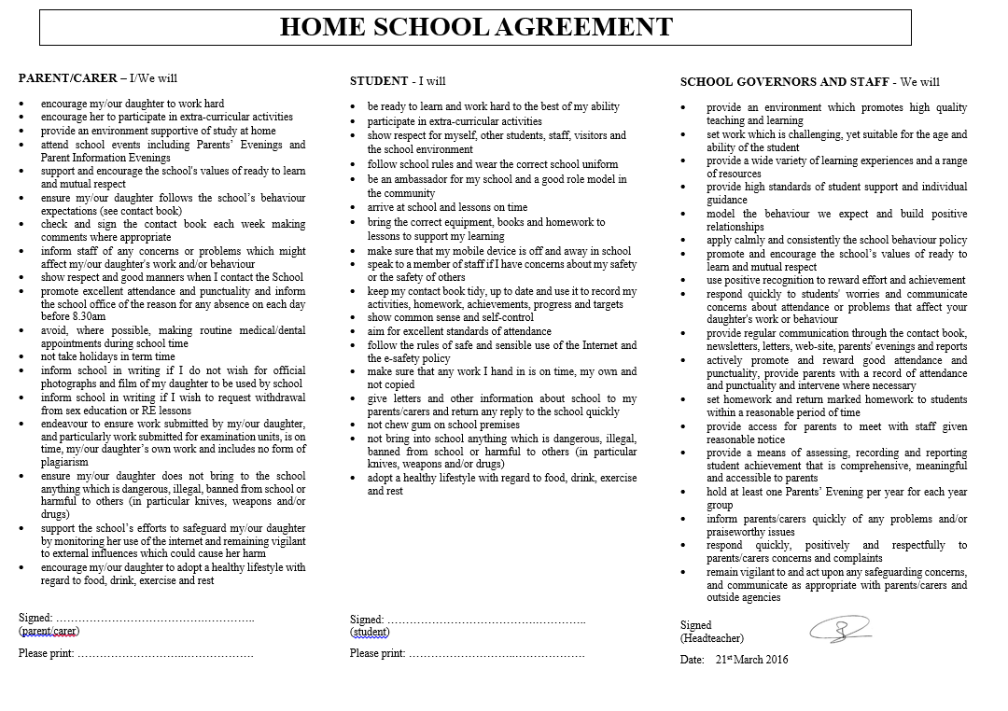

Appendix 2 – Dress Code and equipment for school
Dress Code and equipment for school

Years 7 – 11
All the time that your daughter is in Bullers Wood School uniform she is representing the school. Therefore behaviour whilst in school uniform should reflect the highest of standards, from when she leaves school in the morning until she returns home after school.

Students in Years 7 to 11 are required to wear the correct school uniform at all times unless specifically advised otherwise (eg. for Own Clothes Day to raise funds for charity). Students are also required to wear the correct uniform on school trips unless specifically advised not to.

We believe that uniform serves its best purpose when parents/carers and students conform to the school’s uniform requirements and accept that fashion trends are best left for out of school clothes. We therefore ask that parents/carers exercise careful judgement in matters of uniform and that they check with school any potential purchases which might prove to be controversial and expensive with us before they make them.

All items of uniform and PE kit should be clearly labelled with the student’s name.

Uniform List for Years 7 - 11
- Navy V-neck pullover or cardigan with School Badge*
- “A” line Black Watch tartan skirt with inverted pleats knee length or below*
- Cream blouse with reveres*
- Navy or Black below knee length or short socks, or plain Navy or Black tights - patterned tights are not permitted.
- Black, sensible, low-heeled, traditional, shoes or low ankle boots only, (with black laces if appropriate). No trainers, canvas shoes, open-toes, flip flops, sling-backs or casual style footwear.
- Black plain, fabric coat with long sleeves. (Large logos, denim, leather, suede, PVC and fur coats/jackets are not allowed)
- Plain scarf or hat (optional) in any of the school colours (ie. cream/white/navy/dark green/red/black). This may not be worn in lessons
- A strong waterproof black school bag large enough for A4 books and files.

Protective Clothing and PE Kit
PE Hoodies are only worn in PE lessons or for participation in matches, clubs, etc.

- Apron for Home Economics - Navy with White stripe (can be purchased through HE dept)*
- White Science laboratory coat*
- Trainers
- Hockey or football boots with British Safety Standard studs recommended if taking part in hockey and football
- Bullers Wood PE Kit – polo shirt, track pants or leggings, shorts or skorts, fleece or thermal^^

* items available from Bromley Schoolwear – www.bromleyschoolwear.co.uk
^^ purchased via the PE Department.

Jewellery, Make-Up, Nails and Hair
Jewellery is not part of school uniform. The only items permitted are
- one pair of small, plain silver or gold stud earrings for pierced ears
(one earring in each lower ear lobe) and/or
- a small chain with a religious symbol, if appropriate.
- a watch (which is encouraged).

Other body jewellery, including any form of facial or body piercing (other than earrings in the ear lobe) are not permitted. Student must not cover piercings and think this makes them acceptable.

Students who abuse this system will have their jewellery confiscated.

Make up of any description should not be worn. Students will be asked to remove with wipes or wash it off in the cloakrooms.

Nail varnish, false nails or acrylic nails are not permitted. Students will be asked to remove before returning to lessons).

Hair accessories should be of school colours – cream, white, navy, dark green, red or black. No large flamboyant hair accessories. Hair should be of a natural colour and appearance. No extreme hair styles or shaved hair is allowed. Students may need to spend time in inclusion until this is rectified.

Equipment for school (ready to learn)
- Books for the school day
- Contact book
- Pencil case
- Pens and pencils
- Ruler
- Protractor
- Scissors
- Glue
- Calculator
- Dry wipe pen

Appendix 3 – School Rules
School operates a zero tolerance policy on the following items which are banned from school:
- any substance which is dangerous, illegal, harmful to others (in particular knives, weapons or harmful drugs including alcohol).
- pornographic images or material
- any article that school staff reasonably suspects has been, or is likely to be, used to commit an offence, or to cause personal injury to, or damage to the property of, any person (including the student).
Smoking is not allowed anywhere on school premises, when students are off site wearing school uniform or in proximity of the school site. Students caught smoking, in the company of smokers or in the possession of E-cigarettes, lighters, papers or any form of smoking associated paraphernalia will be referred to inclusion.
Shouting, screaming and unacceptable language (prejudice, swearing, slang, etc) are not allowed on school site.

Appendix 4 – Logging behaviour incidents on SIMS.
There are two levels of behaviour recorded on SIMS. When issues escalate, the most serious issue is logged on SIMS with reference to the primary incident.

B1 – low level incidents  (logged on SIMS by teacher or office for confiscated items)  Initiated/sanctioned by classroom teacher or member of staff on duty or form tutor | B2 – serious or persistent incidents  (logged on SIMS by teacher or office for confiscated items, electronic referral sent to HoY – copy to form tutor)  Sanctioned by TLR holder (HoD/HoY), likely time in Inclusion.
Second incident per half-term of (after initial warning):  - Incorrect dress code (Inclusion if it cannot be rectified)  - Make up (must be removed)  - Jewellery (jewellery must be confiscated)  - Failure to bring the correct equipment or books.  - Unsatisfactory work ethos  - Chewing gum  - Failure to follow school expectations  - Use of unacceptable language  First incident of Mobile device (must confiscated and handed to the office that day) | Refusal to hand over mobile device (must be confiscated)  Abusive language with intent and/or purpose  Persistent uniform, make up or jewellery  Persistent lack of punctuality  Deliberate damage to property  Theft  Threatening behaviour (written/verbal/electronic media)  Physical aggression  Persistent refusal and/or failure to cooperate/follow instructions  Malicious accusation against school staff  Bullying  Bullying racial  Bullying homophobic (or any protected group)  Smoking  Truancy

HoY and AHT to monitor behaviour incident recorded on SIMS.

In addition, all serious allegations of un-proved bullying whether it be racial, homophobic or towards another protected group must be logged and appropriate record kept by the HoY.

Appendix 5 – Duties, Walkabout, On Call, duty DHT/HT

Walkabout (lesson time)
- Collect walkie talkie promptly from Reception.
- Visit locations on the walkabout timetable. Please enter the room, stay for a few minutes or until the member of staff indicates all is well.
- Please ensure you visit cover lessons, preferably in the mid/later part of lesson. Enter the room and stay for at least 5 minutes.
- Please circulate as much of the school as you can, including Inglewood and the Medical Room.
- Vary your route each week.
- Move on students to lessons as quickly as possible.
- If requested by member of staff, accompany a student who is removed from a lesson to the subject exit room and then inform HoD (copying in form tutor and HoY). Check staff have issued a consequence, usually 30 minutes detention that day.
- Question any student out of lesson and escort back to lesson if student does not have a pass in their contact book.
- If a group is dismissed from a lesson early, send back to lesson.
- For serious incidents which would require Inclusion or exclusion, contact on call (duty AHT) for advice on the separation of students and the collection of student accounts.
- Hand over ongoing incidents to Reception or next member of staff.

On Call (usually duty AHT)
- Available to support Walkabout with serious incidents and provide support/advice.
- Must stay by the phone or notify Reception if moving away from the phone.
- Used to co-ordinate the investigation and gathering of Student Accounts for serious incidents.
- Co-ordinate locations of separated students whilst issues are investigated.
- Pass on any investigation to HoY if appropriate or next AHT on call.
- For serious incidents home must be informed as early as possible.

Duty HT/DHT
- Available in emergencies.
- Provide support/advice to the duty AHT re serious incidents.
- Make decisions regarding consequences Inclusion/exclusion (when all student and staff accounts have been gathered).

Appendix 6 – Student Account of Event

Bullers Wood School
Student Account
Your name: | Your form:
Today’s date:

Date of incident:

Where did it happen?

Who else was there?

What happened?

Signed:___________________________________

Appendix 7 - Student report

Form Tutor / Head of Department / Head of Year / AHT / DHT Report (please circle)
Name of student |  | Form |  | Reason

Report to be signed by the teacher at the end of each lesson. It must be taken to _________________ at ____________ each day and signed by parent/carer each evening.

Date | Form Time | Lesson 1 | Lesson 2 | Lesson 3 | Lesson 4 | Lesson 5 | Lesson 6 | Staff | Parent

Please complete boxes using number/grade appropriate to work/behaviour. Any additional comments may be added overleaf. Please give date, subject and comment.
1 A Good
2 B Satisfactory
3 C Some cause for concern
4 D Unsatisfactory
Numbers 1-4  Work | A-D  Behaviour
Report requested by:________________

Appendix 8 – Pastoral Support Plan

BULLERS WOOD SCHOOL

PASTORAL SUPPORT PLAN

Date |  | Formal Review Date

Student Name
Form
Date of Birth
SEN
Ethnicity
Monitoring Teacher

Please attach copy of most recent Academic report

Areas of concern
1.
2.
3.

General Targets
1.
2.
3.

Action Required by Student
1.
2.
3.

Action Required by Parent/Carer
1.
2.
3.

Action Required by School
1.
2.
3.

Other

Agreement
We the undersigned agree with the above targets and actions. We are willing to co-operate and make every effort to ensure the successful completion of the pastoral support plan.

Student |  | Date
Parents/Carer |  | Date
School |  | Date
BBS |  | Date

Appendix 9 - ‘Off and away’ poster

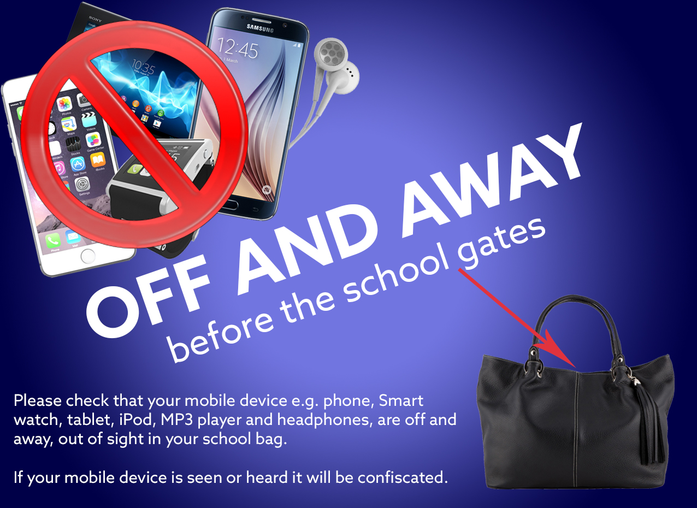

Appendix 10 – Mobile devices and contacting home during the school day
Should a student be observed or be suspected of using a mobile device on the premises, it will be confiscated and handed to the School Office. Confiscated mobile devices are placed in the school safe (that day) and a behaviour point is recorded on SIMS by the office. This triggers an automatic email which is sent to the form tutor and HoY. Students in Yr 7-11 can collect their device at the end of the half-term and students in Yr 12-13 can collect their device on Friday at 3:10pm from the office. Alternatively, a student can ask their parent/carer to come and collect their phone from the school office.

Please note that if a student in Year 7-11 has a mobile device confiscated during the school day and makes contact with home during that day on another mobile device a further consequence will be put in place by the HoY.

When the mobile device is collected by the parent the office staff ask parents to sign a form stating that the parent/carer understands the school policy and will support the school. Repeatedly breaking the school expectations regarding mobile devices will result in a leadership detention.

Return of confiscated mobile device to be signed by parent/carer
Please remind your son/daughter of the following:

We do not allow students to use mobile devices on site. This policy is in place to:

- minimise classroom disruption,
- prevent bullying, and
- restrict student use of inappropriate websites (during the school day).

If students choose to bring mobile devices and headphones into school, they must remain switched ‘off and away’ whilst on site and be stored out of sight in students’ bags.

Sixth Form students are allowed to use mobile devices in the immediate vicinity of Inglewood (this does not include the Sports Hall) but not in their lessons. In Sixth Form lessons mobile devices should not be visible or heard. Mobile devices must be off and away when students exit Inglewood car park as they walk towards the main school. Signs remind students of this rule around site.

Signature:……………………………………………….. Date:……………………………..

Contacting students during the school day
Parents wishing to contact their daughter in an emergency during the school day should contact the School Office to pass on a message, rather than contacting their daughter directly. Please note whilst every effort is made to pass on urgent messages to students in a timely manner this is dependent on staff availability.

If, in an emergency a student needs to call home for an appropriate reason:
- money on Squid,
- cancelled club or visit or
- with written note from a form tutor or HoY

This can be done outside of lesson time via the Reception desk, form tutor or HoY. Students may not ring home to request books, equipment, or to tell parents their mobile device is confiscated, etc.

Appendix 11 - Reasonable Force (guidance for staff)
The term ‘reasonable force’ covers the broad range of actions used by most teachers at some point in their career that involve a degree of physical contact with students.
Reasonable force (no more force than is needed) can be used to prevent students from hurting themselves or others, from damaging property, or from causing disorder.
In a school, force is used for two main purposes – to control students or to restrain them.
Control means either passive physical contact, such as standing between students or blocking a student's path, or active physical contact such as leading a student by the arm out of a classroom.
Restraint means to hold back physically or to bring a student under control. It is typically used in more extreme circumstances, for example when two students are fighting and refuse to separate without physical intervention.
The decision on whether or not to physically intervene is down to the professional judgement of the staff member concerned and should always depend on the individual circumstances.

School staff should always try to avoid acting in a way that might cause injury, but in extreme cases it may not always be possible to avoid injuring the student.

The following examples outline some circumstances when reasonable force might be used:

• remove disruptive children from the classroom where they have refused to follow an instruction to do so (note remove other students first);
• prevent a student behaving in a way that disrupts a school event or a school trip or visit;
• prevent a student leaving the classroom where allowing the student to leave would risk their safety or lead to behaviour that disrupts the behaviour of others;
• prevent a student from attacking a member of staff or another student, or to stop a fight; and
• restrain a student at risk of harming themselves through physical outbursts.

We have a legal duty to make reasonable adjustments with regard to the use of reasonable force with disabled students and those with SEN.
Parents will be informed when reasonable force has been used and such incidents will be recorded on SIMS as part of the usual behaviour referral system.

Please consult the link below for additional advice regarding:

Use of reasonable force
https://www.gov.uk/government/uploads/system/uploads/attachment_data/file/444051/Use_of_reasonable_force_advice_Reviewed_July_2015.pdf

