Bullers Wood School
Sixth Form
Be part of our success story
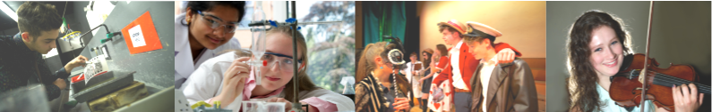

Art A Level

Why study this subject?
Art and Design is both a form of communication and a means of expression of ideas and feelings. It forms a language which complements those of the literary, mathematical, scientific and factually based subjects and is especially concerned with the development of those complex mental processes involved in visual perception and aesthetic experience.

Entry Requirements
Students need to gain five A*-C grade GCSEs including English Language and Mathematics at grade 4, plus a B grade in Art.

Content
A level Art is intended to provide students with opportunities to develop personal responses to ideas, observations, experiences, environments and cultures in practical, critical and contextual forms. The syllabus has been designed to combine the necessary breadth, depth and freedom of choice required to accommodate a wide range of abilities.

Assessment
There are two components at A Level which are compulsory. A Level work is internally assessed and externally moderated. You will put up an exhibition of your work at the end of the course.
Component 1 (60 % of final mark):
- Coursework Folder – A portfolio of work is presented for examination and should show a selection of work which can include sketch-book, life-drawing, course set projects, gallery and exhibition visits, photographs and other forms of research, plus specialist projects.
- Personal Study – Critical and visual appraisal or theoretical study of any aspect of the visual arts. The title is chosen by the student with the support of teachers, and students respond with a body of research and practical responses followed by an essay of up to 2000 words to complete this unit.
Component 2 (40 % of the final mark):
- The Controlled Assignment – This component is set by the examining board and examination papers are given out well in advance of the test (at least 6 weeks) so that preparation can be made well in advance of the exam.

Future courses and possible careers
The course at Bullers Wood has a well established reputation for placing students on top BTEC Foundation Courses such as St Martins, Chelsea, Camberwell as well as Ravensbourne and Rochester. We also encourage direct entry to visual arts degrees in a variety of institutions around the country through the UCAS admission scheme. Past and recent career paths include teaching, computer animation, illustration, graphics, fashion and fashion accessories, architecture, conservation and many others.

