Bullers Wood School
Sixth Form
Be part of our success story
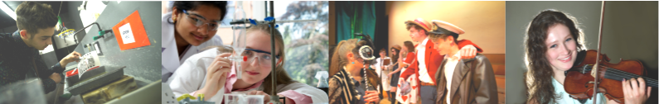

Art, Fashion and Photography
NQF BTEC Level 3 Extended Diploma (Art and Design) in Art, Fashion and Photography

Why study this subject?
The course aims to develop creativity and confidence in the ability to think, question, explore, create and communicate. Students use these skills in real life situations, such as to organise and run a fashion show to raise money for charity. Workshops are run to enable students to gain the necessary skills in contextual studies, textile and material manipulation, fashion illustration, photography and specialist art skills.

This course is equivalent to three A Levels and it is not normally possible to combine it with any other qualifications.

Entry Requirements
Students need to gain five A*-C grade GCSEs including English Language and Mathematics at grade 4.

Content
BTEC Extended Diploma in Art, Fashion and Photography is intended to provide students with opportunities to develop personal responses to ideas, observations, experiences, environments and cultures in practical, critical and contextual forms. The syllabus has been designed to combine the necessary breadth, depth and freedom of choice required to accommodate a wide range of abilities. No previous knowledge of Photography is necessary to join the course. However possession of a 35mm SLR camera is essential. The course includes some form of experimental work and the acquisition of technical skills in chemically based Photography as well as Digital Photography.

Assessment
Students are assessed on coursework modules and a set of tasks set by Edexcel.

Coursework Folder
A Coursework Folder is created in response to unit briefs. As units progress students will be expected to evaluate and analyse their own work. This course will include gallery and field visits, experimental work and formal technical information.

Externally Assessed Assignment
The completion of four practical tasks under controlled conditions with work reflecting skills learnt during the course and within the coursework portfolio.

Future courses and possible careers
Past students have gone on to higher education in the visual arts. This has included Foundation courses and direct entry to Photography BA Honours, degrees at various institutions both in London and around the country. Other career pathways include Graphic Design & Advertising, Fashion Photography and Fashion Merchandising etc.

NB Please be aware, that specialist equipment is required for the course and this could be expensive.

