Bullers Wood School
Sixth Form
Be part of our success story
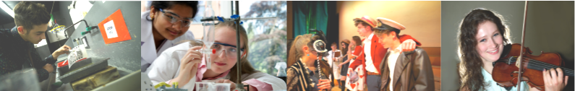

Sport
BTEC Level 3 National Extended Certificate in Sport

Why study this subject?
This course, which is equivalent to one A Level, is for students wanting to continue their education through applied learning, who aim to progress to higher education and ultimately to employment, possibly in the sports sector.

Entry Requirements
Students need to gain five A*-C grade GCSEs including English Language and Mathematics at grade 4.

Content
Anatomy and Physiology (Examination)
The examination will be one hour and 30 minutes in length. Pupils will explore the structure of the skeletal, muscular, cardiovascular, respiratory and energy systems as well as additional factors which affect sport and exercise performance. The anatomy and physiology of each body system and their processes are very different but work together to produce movement. Pupils will gain a full appreciation of how the body is able to take part in sport and exercise through understanding the interrelationships between these body systems.

Fitness Training and Programming for Health, Sport and Well-being (Set task)
In this unit, you will explore the process required for screening clients and assessing their lifestyle and nutritional intake. How to interpret this information will then be examined. From this information you will explore how to make judgements on a specific individual’s current lifestyle and then suggest modifications to help improve the individual’s fitness, health and overall well-being. Fitness training methods will be examined for each component of physical and skill-related fitness.

Professional Development in the Sports
In this unit, you will research the different possible careers and the associated job roles in the sports industry, then action plan your development towards achieving a selected career aim. You will analyse your own skills and identify how to develop them into a career through the use of a career plan. You will research your chosen career to understand how to access and progress within it.

Assessment
Pupils will complete 4 units, two of those units are externally assessed and the other two units are internally assessed.

External Assessment
The styles of external assessment used for BTEC Sport are:
- Examinations – all students take the same assessment at the same time, normally with a written outcome
- Set tasks – students take the assessment during a defined window and demonstrate understanding through completion of a vocational task

Externally assessed units are:
- Anatomy and Physiology (Examination)
- Fitness Training and Programming for Health, Sport and Well-being (Set task)

Internal Assessment
Students could be given opportunities to:
- write up the findings of their own research
- use case studies to explore complex or unfamiliar situations
- carry out projects for which they have choice over the direction and outcomes
- demonstrate practical and technical skills

The mandatory coursework unit is:
- Professional Development in the Sports

The last coursework unit is optional from the following units.
- Sports Leadership
- Application of Fitness Testing
- Sports Psychology
- Practical Sports Performance

Future courses and possible careers
The qualification carries UCAS points and is recognised by higher education providers as meeting or contributing to, admission requirements for many relevant courses. Students can progress to higher education, for example:
- BA (Hons) in Sports Development and Management
- BSc(Hons) in Sports Management
- BSc(Hons) Sports Business Management
- BSc(Hons) Sport and Leisure Management
- BSc(Hons) Sports Science (Outdoor Activities)
- BSc (Hons) in Exercise, Health and Fitness
- BSc (Hons) in Sport and Exercise Psychology

