|  |  |
| --- | --- |
| **Bullers Wood School**  **Sixth Form**  ***Be part of our success story*** |  |

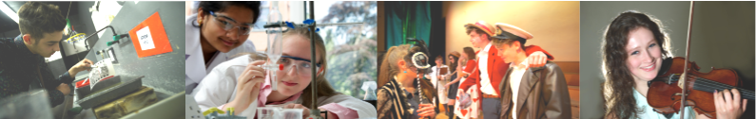

**Photography**

**NQF BTEC Level 3 Extended Certificate (Art and Design) in Photography**

**Why study this subject?**

Like Art, Photography is both a form of communication and a means of expression of ideas and feelings. It forms a language, which complements those of the literary, mathematical, scientific and factually based subjects. It is also especially concerned with the development of those complex mental processes involved in visual perception and aesthetic experience.

**The course is equivalent to one A Level.** Please note that the BTECs in Fashion and Photography cannot be taken together. Students wishing to do this combination should take the Art and Design BTEC Level 3 Extended Diploma (Fashion and Photography).

**Entry Requirements**

Students need to gain five A*-C grade GCSEs including English Language and Mathematics at grade 4.

**Content**

At BTEC Level no previous knowledge of Photography is necessary to join the course. However possession of a 35mm SLR camera is essential. The course includes some form of experimental work and the acquisition of technical skills in chemically based Photography as well as Digital Photography. Students can choose to specialise in the area which most interests them, such as image capture/manipulation, darkroom/digital techniques or studio/location photography.

**Assessment**

Students are assessed on coursework modules and a set of tasks set by Edexcel. These modules are designed to develop an understanding of the links between commercial photography and digital recording whilst developing the skills needed to become a creative photographer.

**Coursework Folder** – A Coursework Folder is created in response to unit briefs. As units progress students will be expected to evaluate and analyse their own work. This course will include gallery and field visits, experimental work and formal technical information.

**Externally Assessed Assignment** –The completion of two practical tasks under controlled conditions with work reflecting skills learnt during the course and within the coursework portfolio.

**Future courses and possible careers**

Past students have gone on to higher education in the visual arts. This has included Foundation courses and direct entry to Photography BA Honours, degrees at various institutions both in London and around the country. Other career pathways include Photojournalism, Graphic Design and Advertising, Medical Photography, Forensic Photography, Media Industry and Television, Aerial Photography, Fashion Photography etc.

**Please be aware that specialist equipment and materials will be required and may be expensive.**

