Bullers Wood School
Sixth Form
Be part of our success story
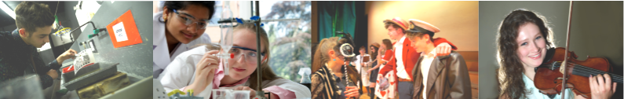

Dance A Level

Why study this subject?
This is an interesting and absorbing course designed for those students who have a background in dance, either technical or free expressive movement, or a student who has the desire and ability to move fluently. It aims to develop a creative and visionary ability for choreography and performance. Knowledge will be gained in technical skills and all aspects of Dance, its interpretation, evaluation and its relation to the other arts. The students will enjoy working and creating dance works together, experiencing and appreciating the skills of well-known choreographers. The course, while requiring dedication and hard work also generates a personal sense of joy and fulfilment for students entering the creative dimension of dance.

Entry Requirements
Students need to gain five A*-C grade GCSEs including Mathematics at grade 4, grade 5 in English language and B grade in Dance, if studied, together with a proven interest and ability in Dance.

Content
- Own Practice (including anatomy, nutrition, injury and injury prevention)
- Relevant Dance History
- Choreography (including the analysis of the constituent features of professional repertoire)
- Compulsory Study Area (Rambert 1966 – current day) plus one other study area selected from a choice of five
- Set Dance Work (Rooster by Christopher Bruce) plus a second dance work connected to the optional study area

Assessment
Written Exam (50% of the final grade)
Section A: Short answer questions (25 marks) and one essay question (25 marks) on the compulsory set work/area of study.
Section B: Two essay questions on the second set work/area of study (25 marks for each essay).

Practical Exam (50% of the final grade)
Solo Set Technical Study.
Performance in a Quartet.
Group Choreography.

Future courses and possible careers
Dance/ Musical Theatre Degree at a specialised institution or university.
A range of performance/choreographic careers in Dance and related performance areas.
Dance Teacher/ lecturer and careers in education/community.
Arts Management or administration.
Costume/ lighting design etc.
Physiotherapy/injury prevention.

