**Art, Photography and Fashion**

The Art and Photography department offers Art and Design at KS3 in mixed ability groups.  
Students are encouraged to experiment with a range of media and are taught key skills in drawing, painting, sculpture and critical analysis.

Art and design is offered at GCSE and in the 6th form Art, Photography and Fashion are offered at A Level and BTEC. Many students go onto Art College to study a range of visual courses at Foundation and at degree level.

**Staff**

Mrs Gudge - Head of Art and Photography Miss Noble

Ms Bellis - Director of 6th Form Mrs Purcell

Mrs Blanks - BTEC Coordinator Miss Russ

Ms Doughty Miss Warriner

Mrs McCarthy - Support Technician

Mrs Ward - Support Technician

**Key Stage 3**

**Year 7 Topic** Natural Forms

Artist links: William Morris, Georgia O’Keeffe and Aboriginal art

Outcomes: Drawing (repeat pattern William Morris), painting (close up observation of a flower O’Keeffe) and 3D piece (make digeridoo or boomerang)

**Year 8 Topic** Surrealism

Artist links: Rene Magritte, Surrealist artist for 6th Form fashion show and Friedrich Hundertwasser

Outcomes: Painting (in response to Magritte), 3D accessory/clothing (to be modelled in Fashion Show) and Graphic drawing (in response to Hunderwasser)

**Year 9 Topic** Great British Values

Artist links: Greyson Perry, Pop Art and Yinka Shonibare

Outcomes: Mixed media collage (in response to Perry), 3D accessory/clothing (to be modelled in Fashion Show Pop art) and Graphic drawing (in response to Shonibare)

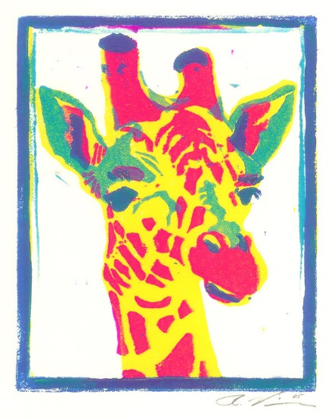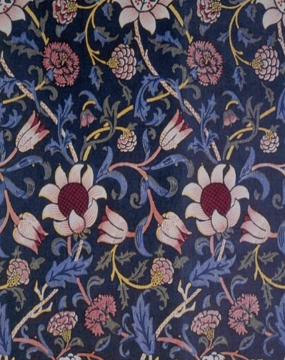

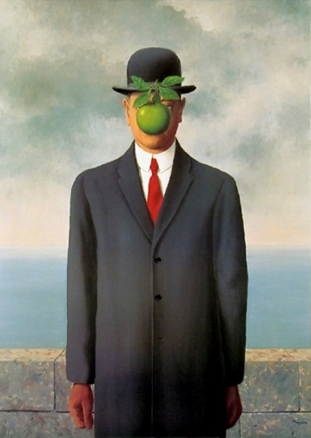

**Computer Science**

The Computer Science department are extremely supportive to all students following Computer Science courses and students using the computer facilities for other subjects during the homework clubs.   We have an excellent record of examination results and are extremely keen to keep up-to-date with new developments in technology.  We enjoy excellent facilities and in particular our class set of Raspberry Pi’s, which are used to build basic computer rooms.  Students are taught in dedicated ICT suites with one PC per child and a range of software including industry standard programs.

**Staff**

Mr Johnson - Head of Computer Science

Ms Hoffman

Mr Khan

Mrs Krissan

**Key Stage 3**

**Year 7 Topics**

Students study a variety of both ICT and Computer science skills including: An introduction to software and hardware components; an e-safety project using a simple system life cycle model; spreadsheet modelling; an introduction to simple databases. An introduction to simple programming skills using at least two different programming environments; as well as animation, graphics and design work. Students also get to explore some of the History of Computer systems and how much they have changed in such a short time.

**Year 8 Topics**

Students study a variety of Computer science skills including: An Introduction to more advanced programming features, mainly using the Python programming language. They explore Computer Fundamentals and gain a better understanding of computers and associated Internet technologies.  They learn about Computer crime and cyber security.  Students generally learn how to use problem solving techniques to deal with different scenarios.

**Year 9 Topics**

**Computer Science**

Students study some of the key theories in Computer Science. In the first strand they look into Computer Systems, which gives them insight into how the Computer and its components really work. They learn more about security concerns, ethics and the laws surrounding the use and development of computer systems. The second strand is computational thinking. In this strand they focus more on developing their computational thinking, programming skills and the logic surrounding how computers save information.

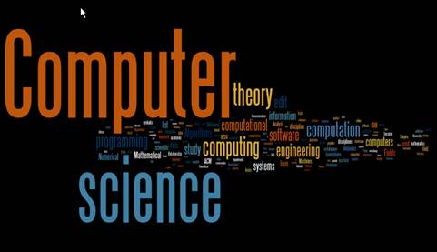

**Drama and Theatre Studies**

The Drama department and its students are a lively, friendly and supportive community of performers, designers and technicians. The ethos of the department is to provide an enjoyable, challenging and creative environment where students learn to develop confidence, gain an awareness of the world around them, and can perform and share their work with others.

**Staff**

Mrs Anderson - Head of Drama

Mrs Bannister

Mrs Seall

We are fortunate enough to have two dedicated Drama studios and a proscenium arch stage with dressing rooms, fully equipped with lighting and sound facilities. This provides students with the unique experience of working in versatile spaces with regular opportunities to perform. The Department staff are highly experienced and have worked in Arts industries as well as education.

**Department Aims**

We strive to constantly develop students’ creative and evaluativeskills in Drama. Teamwork is an essential element of effective learning and students are encouraged to develop empathy by engaging with complicated real life issues. All students are supported to share their ideas, listen carefully to each other and perform their work to an audience. We aim to expose our students to a wide variety of theatre styles, techniques and live performances in a range of settings.

**Key Stage 3 Drama:**

|  |  |  |  |  |  |
| --- | --- | --- | --- | --- | --- |
|  | **Year 7** | | **Year 8** | | **Year 9** |
| **Autumn 1**  **7 weeks** | **Circus**  **(skills based)** | | **Pantomime / Melodrama**  **(skills based)** | | **Monologues /duologues**  **(skills based)** |
| **Autumn 2**  **7 weeks** | **A Christmas Carol**  **(Script)** | | **Wreck of the Mignonette**  **(SMSC/historical)** | | **Devising – Cultural stories**  **(SMSC)** |
| **Spring 1**  **6 weeks** | **Spears Sports**  **(Bullying/SMSC)** | | **Roald Dahl**  **(script)** | | **Stone Cold**  **(script)** |
| **Spring 2**  **6 weeks** | **A Midsummer Night’s Dream**  **(Shakespeare)** | | **Joe – Mental Health awareness project**  **(SMSC)** | | **Script based performance**  **Masks project**  **(skills)** |
| **Summer 1**  **6 weeks** | | **Summer Exam**  **Devising from theme**  **Performance in Summer 2** | | **Summer Exam**  **(SMSC stimulus)** | **Summer Exam**  **Devising – TIE/Forum Theatre**  **Cyber-bullying or chosen theme** |
| **Summer 2**  **6 weeks** | | **Performance**  **Greek Theatre**  **(SMSC)** | | **Macbeth**  **(Shakespeare)** | **Devising – TIE**  **Cyber-bullying or chosen theme**  **Performance to younger audience** |

**Cross- curricular opportunities**

The Drama department aspires to work collegiately across all subjects and disciplines to enhance the learning experience for students. Recent collaborative projects have included study and performance of ‘A Christmas Carol’ in English, Music, Dance and Drama, and a Personal, Social and Health Education initiative using Drama to facilitate and deliver awareness of Healthy Relationships.

**Extra-curricular opportunities**

* Whole school production annually
* KS3 Drama Club - student led
* Technical Theatre Club for lighting, sound, costumes and propos
* LAMDA examinations offered across all Key Stages
* Performances in the local community, including primary schools and care homes for the elderly
* Visits to local and national theatres
* Participation in outreach projects with professional actors and theatre companies

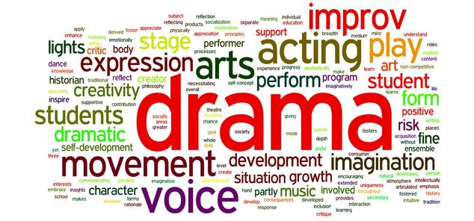

**Design and Technology**

Design and Technology is a highly practical subject which develops a student’s ability to work independently and creatively in a variety of materials. The subject is taught through a series of projects with a core of theoretical knowledge and understanding to support the designing and making process. Students design considering the needs of the target market and consider social and ethical values.

Lessons are taught through a rotation of textiles, resistant materials, electronics, graphics and systems and control. CAD/CAM facilities are excellent and the department has 5 specialist material rooms including an ICT suite.

**Staff**

Mrs Kempster - Head of Design and Technology

Ms Bellis

Mrs Kay

Mrs Purcell

Miss Wainwright

Mr Fielder - Support Technician

**Key Stage 3**

**Year 7** Students learn skills in textiles through a batik project, resistant materials through a picture frame unit and graphics by developing a pop-up book. In systems and control students make an electronic badge and simple circuits.

**Year 8** Students build on their designing and making skills through a mechanical toy project, and a textiles 3D make. They develop enamel jewellery in resistant materials and package their design in graphics using CAD CAM.

**Year 9** Student’s skills are increasingly challenged through complex design and make projects with the tote bag project and the CAD CAM resistant materials clock project. Students are expected to use modern and developing technologies in Year 9.

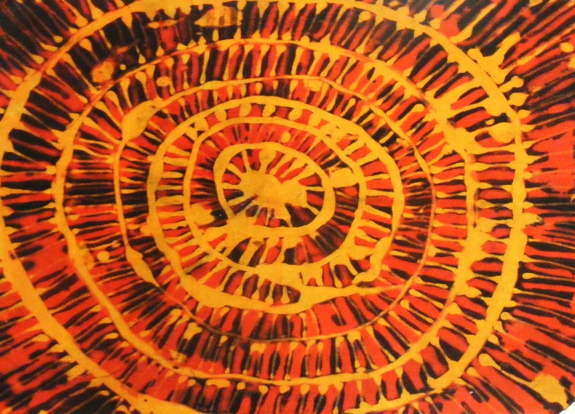

**English**

Our English curriculum is rich, varied and challenging.  Students read texts from a range of historical periods and cultural contexts across the genres of drama, poetry and prose.  Students learn to develop their writing skills to inform, explain, describe, argue and persuade in lively and imaginative contexts which inspire as well as equip them for life beyond the classroom.  Students can expect to explore and enhance their speaking and listening skills through role-play, discussion and presentation.  English Literature and English Language are popular subjects which a large number of students choose to pursue at A Level.

**Staff**

Ms Heaney - Head of English Mrs Burke

Ms Smythe – 2nd in English   Ms Gowing - Library Liaison

Ms Petersen - Head of English Language Mrs Haslam - Public Speaking/G&T Co-ordinator

Mrs Akil  Ms McHale

Ms Bell Mrs Mitchell

Mr Benson  Mr Polak

Ms Buckingham

**Key Stage 3**

**Year 7 Topics** Autobiography

A Christmas Carol

Non-Fiction: Lord Lucan

Poetry

Novel

The Tempest

**Year 8 Topics** Modern Novel

Gothic Writing

Non-Fiction: Travel Writing

Sherlock Holmes

Shakespeare Play

**Year 9 Topics** Poetry: World War One

Romeo and Juliet

Non-Fiction: Teenage Texts

Speeches

Modern American Novel

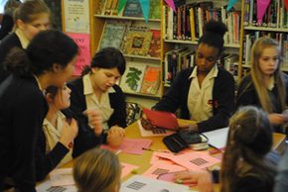

**French**

All the teaching in Year 7 takes place in mixed ability groups to allow students to settle into their new school. However, from year 8 onwards, they are taught in sets based on their achievement at the end of Year 7. Sets are reviewed on a termly basis.

**Staff**

Mr Parsons - Head of French

Ms Conget - KS3 French Co-ordinator

**Key Stage 3**

**Year 7 Topics** Introducing yourself

School equipment

Family members and pets

Personal descriptions

School: subjects, opinions and reasons, timetable

Daily routine



**Year 8 Topics** Where you live: area and house

Describe your bedroom and where things are

Evening routine

Places in town

Directions

Ordering food and drinks

Sports and games

Musical instruments

Leisure and holiday activities

Introduction to the perfect tense

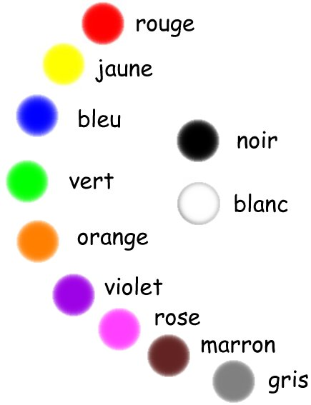

**Year 9 Topics** Talking about your family

Occupations and places of work

Describing weather

Last week-end activities

TV programmes

Last holiday and next holiday

Pocket money, presents and gadgets

Shopping for clothes

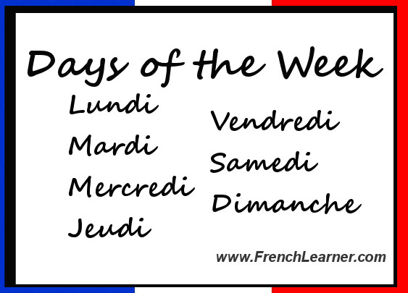

**German**

All the teaching in Year 7 takes place in mixed ability groups to allow students to settle into their new school. However, from year 8 onwards, they are taught in sets based on their achievement at the end of Year 7. Sets are reviewed on a termly basis.

**Staff**

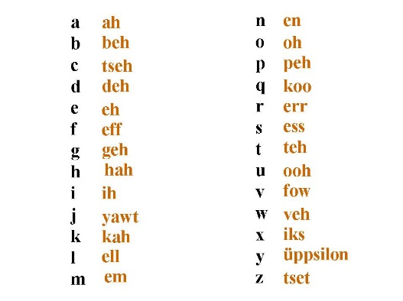Mrs Patel - Head of German

**Key Stage 3**

**Year 7 Topics** Introducing yourself, saying where you live

Alphabet

Birthdays

Numbers to 60

School equipment

Family members and pets

Personal descriptions

School: subjects, opinions and reasons, timetable

**Year 8 Topics** Sport

Hobbies

Favourite things

Writing a letter to a penfriend arranging to go out

 Future Tense

Holidays

Describing your house

**Year 9 Topics** TV programmes

Hobbies

Describing a day out

Food

Café

Shops

Future Tense

Clothes

Party language

Excuses

Health

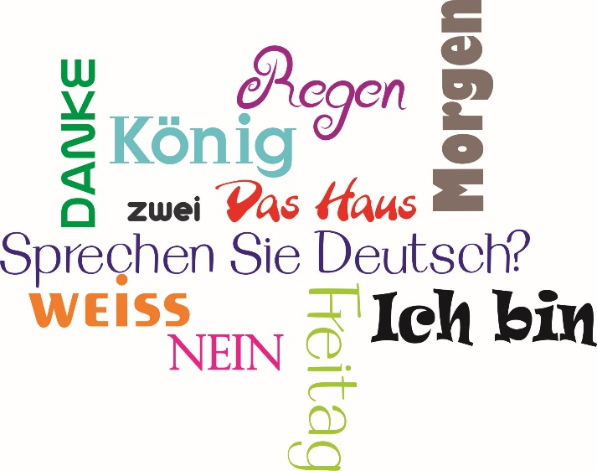

**Geography**

Geography is the study of Earth’s landscapes, people, places and environments. It is, quite simply, about the world in which we live. The subject is taught through investigating a variety of human and physical topics. Fieldwork is a big part of Geography and we try to include as much in the curriculum as possible.

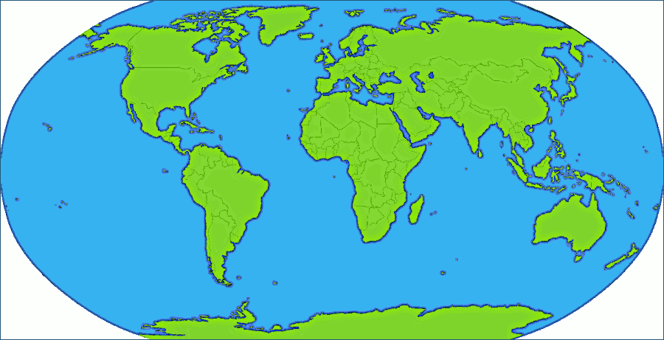**Staff**

Miss Kincaid - Head of Geography

Miss Chan

Miss Giacopazzi

Mrs Wilson

**Key Stage 3**

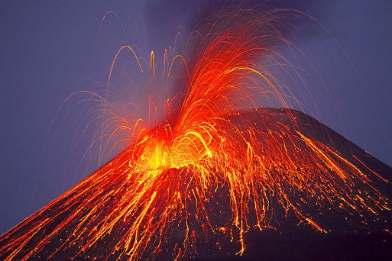**Year 7 Topics** What is Geography?

The UK

Map Skills

Weather and Climate

Sustainability

India

Paradise Lost – Thailand

Trip: Local area

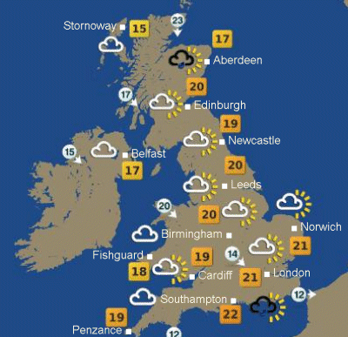

**Year 8 Topics** World Maps

Rivers & Flooding

China

Coasts

Antarctica

Africa

Trip: Brighton and Cuckmere haven

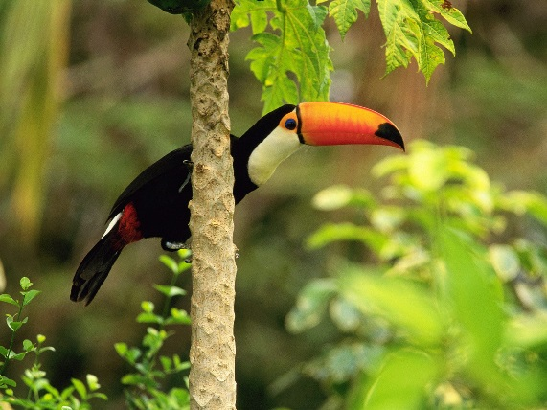**Year 9 Topics** Earthquakes and Volcanoes

Globalisation

Brazil and Tropical Rainforests

Impossible Places

Trip: Kew Gardens

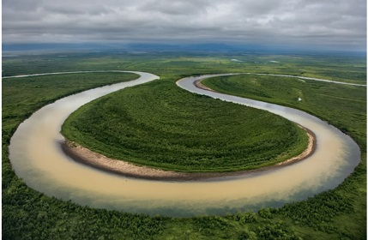

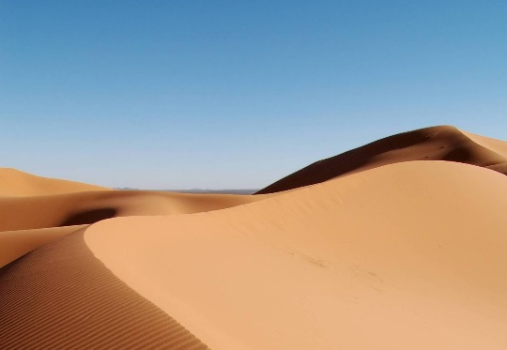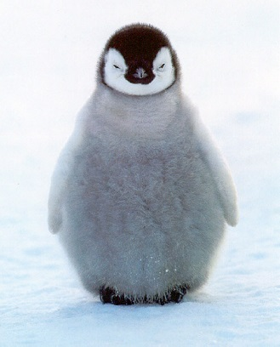

**History**

Teaching during Years 7-9 mixes project work, to encourage independent learning, with direct teacher instruction. The purpose of Year 7-9 history is to establish the basic skills required to access the GCSE and A Level courses while also equipping all students with an overview of British History from 1066 to the 20th Century. The GCSE and A Level courses are focused on political history, and require a high level of literacy and motivation on the part of the students. There is no setting by ability in history in any Year group.

**Staff**

Miss Levey - Head of History

Mrs Beckett

Miss Brown

Mr Greene - Headteacher

Mrs Housden

Ms Wiffen

**Key Stage 3**

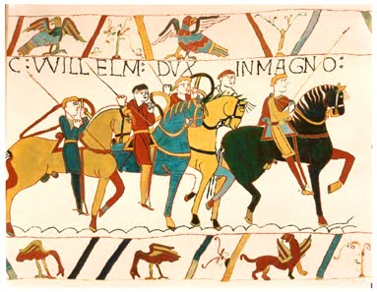**Year 7 Topics** 1066

Norman Conquest  
Medieval Society  
Changes to the Church  
Peasants’ Revolt  
Magna Carta  
Crusades

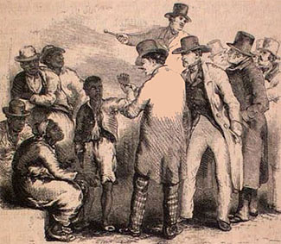**Year 8 Topics** Tudor Monarchs  
 Break With Catholic Church  
 Spanish Armada  
 Gunpowder Plot  
 Great Fire and Plague

Civil War  
Making of the UK  
Slavery  
Empire  
Industrialisation

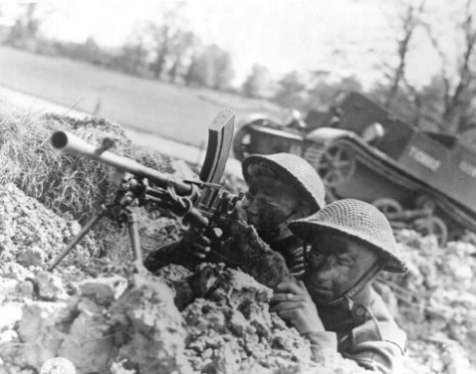**Year 9 Topics** 20th Century, including:

WW1  
Rise of Dictators  
Different Political Ideologies  
Civil Rights  
WWII  
Home Front

**Hospitality and Catering**

Catering and Hospitality Department is part of the Applied Learning faculty. There are two well-resourced catering-style kitchens/classrooms, staffed by highly trained Food/Catering teachers. There is also the provision of training restaurant that allows students to work in a professional environment, giving them valuable work based skills. KS3 follow D&T programme of study, KS4 WJEC exam board and in KS5 OCR exam board

**Staff**

Mrs Shapcott - Head of Hospitality and Catering

Mrs Hemmings

Mrs Kay

Mrs Petty

Mrs Pugsley - Support Technician

**Key Stage 3**

Pupils are taught on a rotational system with the other Design and Technology subjects. They have approximately 12, 1 hour 40 minute lessons each year, most of a practical nature. Groups are mixed in ability.

**Year 7 Topics**

Pupils gain a lot of experience working with a wide range of ingredients and developing new skills. They learn knife skills and how to work safely and hygienically in a commercial-style kitchen. Theory work is investigating dairy products, researching nutrients in dairy products and uses of dairy products in cooking. They design and plan their own layered dessert for future sale in a supermarket. They develop a range of practical skills enabling pupils to bake scones, Fruit crumble, pizza, prepare a healthy salad, prepare a meat based sauce and a cheese sauce.

**Year 8 Topics**

The focus in year 8 is to develop and improve skills taught in year 7. They gain experience in pastry making, preparing sweet and savoury products using different types of pastries. They explore ingredients from around the world, building on knife skills and improving confidence in preparing dishes using the hob. They design and plan their own cookies, make and shape bread dough and practice cake making methods. They widen their vocabulary by tasting fruits from around the world and evaluate their own dishes. Theory work is based around ethical and moral issues on food miles and food waste.

**Year 9 Topics**

Pupils investigate Nutrition in detail, planning their own meals to help patients lacking in certain nutrients. They investigate the uses of convenience foods in their diet and plan a healthy meal using convenience products. They study alternative diets for those with different moral and ethical beliefs, completing a research project on vegetarianism. They develop more complex practical skills in preparing main course dishes, cake making and pastry making, and look at the uses of eggs in cooking.

**Italian**

Year 8 students are taught in an upper and mixed-lower sets based on their achievement at the end of year 7. Sets are reviewed on a termly basis.

**Staff**

Mr Parsons - Acting Head of Italian

Ms Tapinassi

**Key Stage 3**

**Year 8 Topics** Describing my home and bedroom, furniture, describing a famous person, shopping, food and quantities, cost and prices, body  parts and ailments, keeping fit, sports, week-end plans, food and drink for different meals, what activities can be done in town, talking about last week-end, understanding and giving directions, describing the weather.

**Year 9 Topics** Clothing and fashion, revision of colours, TV programmes and films, cinema dialogues, talking about what you saw (past tense), arranging to meet up with someone, giving an excuse, describing daily routine, talking about future intentions, celebrations and festivals in Italy and the UK, describing a past celebration, modes of transport, holidays in the present and past tense, being able to buy a ticket for train/boat ride in Italian.



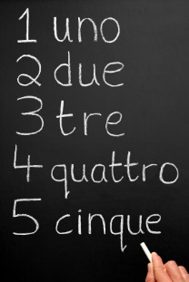

**Mathematics**

Mathematics is compulsory for all students from year 7 through to year 11. The department operates a setting policy based on ability and prior attainment. Students are able to move between sets from year to year if their attainment indicates this is appropriate. All students are entered for GCSE Mathematics at the end of year 11 and students are set challenging target grades to achieve. The most able students are also entered for the Further Mathematics GCSE in year 11. In Key Stage 5 the department offers Mathematics and Further Mathematics and uptake to these is high.

**Staff**  
Mr Leaton - Head of Mathematics Mr Runacres

Mrs Sudds - 2nd in Mathematics Mr Teverson

Miss Curling - KS3 Co-ordinator Mrs Tibbets

Mrs Dhar Mr van Teutem

Mr Leonard - Mathematics ICT Co-ordinator Mr Whittaker

Mrs Paton Mrs Woodhams

**Key Stage 3**

Students will study a variety of topics. These include the strands of number, algebra, graphs, geometry and statistics. Particular emphasis is placed on algebra, developing problem solving skills, arithmetic techniques and accurate use of correct mathematical language and notation. The students are both challenged and supported. The pupils are assessed on a regular basis to monitor their progress. If a student is struggling, additional support will be put in place to help.

The formal start of the GCSE course in mathematics begins in year 9. We follow the Edexcel course, with the majority of students entered at the higher tier.



**Music**

Students study Music for one period a week in Years 7 to 9.  They can then opt to study the subject at GCSE if they wish.  There are numerous opportunities for students to engage in instrumental lessons or join the many bands or choirs.

**Staff**

Miss Bowman

Mr Parsons

**Key Stage 3**

**Year 7 Topics** Singing

Rhythm

Pitch and Notation

Keyboard Skills

Instruments of the Orchestra

The Music of the Caribbean

**Year 8 Topics** Keyboard skills and Notation

Chords

Melody Writing

Theme and Variations

The Music of Africa

**Year 9 Topics** Keyboard Skills

Blues

Reggae

Form and Structure

Music and Media

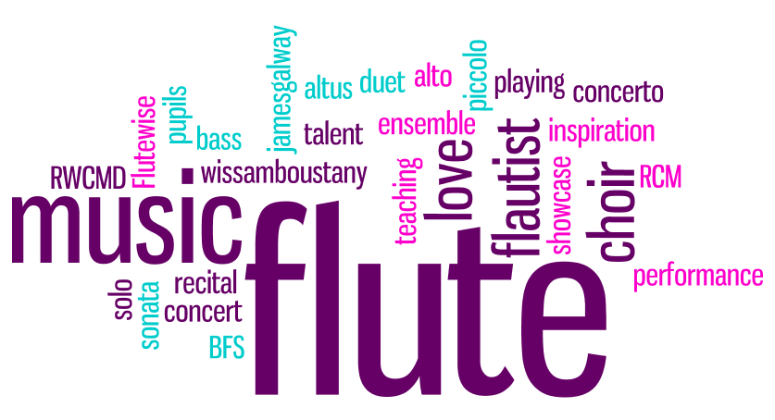

**PE**

Physical Education makes a valuable contribution to the education of every student at Bullers Wood School. We offer a varied and personalised curriculum which enables each individual pupil to develop physical qualities as well as communication skills, self-confidence and teamwork. The department promotes a whole school team ethos through inter form competitions, sports day and our annual sports awards evening. Extra-curricular is a priority with extremely high numbers attending our sports clubs and the department has strong links with the community through our extensive Sports Leadership award programme. We hope to encourage students to take the right path in leading a healthy and active lifestyle.

**Staff**

Mrs Williams - Head of PE

Ms O’Hanlon - Head of PE

Ms Keen

Ms Sydney

Ms Venton

**Key Stage 3**

**Year 7**

Students will begin Year 7 with a 4 week initial assessment of the physical ability, based on Gymnastics, Aerobic capacity, Games and Multi-skills. They will then be set into ability groups and will follow a rotation system covering variety of activities throughout the academic year. The activities studied include: Football, Rugby, Netball, Multi-skills, Dance, Gymnastics, Athletics, Tennis, Rounders, Cricket, and Cross Country.

**Year 8/9**

Students will remain in ability sets within PE and will follow a similar rotation system throughout Year 8. In Year 9, they are then streamed into a personalised programme where they will focus on sports or activities that they may follow at GCSE level. These are usually in a pathway related to their strengths. Further activities will also be introduced such as Trampolining and Badminton.

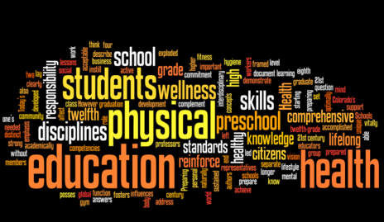

**Religious Studies and Philosophy**

Our curriculum is consonant with the Bromley Agreed Syllabus for Religious Education (2013). It aims to nourish a rigorous understanding of religion, to foster respect for difference, and to promote powers of independent thought.

The school RE policy, approved by Governors in July 2014, is available in the Policy section of the school site.

**Staff**

Mr Stone - Head of RS and Philosophy Mr Khan

Mrs Clark Ms van Teutem - Assistant Headteacher

Miss Clothier Ms Wakenshaw

Miss Hassan

**Key Stage 3**

**Year 7** Pupils participate either in a systematic programme of dialogical philosophy or in more traditional religious education lessons. In dialogical philosophy, pupils engage with religious concepts, the philosophy of religion, and religious ethics. In the traditional curriculum, subject matter includes the nature and value of Religious Studies, God, and symbols and myths. At the end of Year 7, pupils engage in the study of Islam through project-based learning. This is carried out in collaboration with the Islamic SACRE representative and Darul Uloom (London) school. There is one 30 minute baseline exam at the beginning of the school year, and one 30 minute exam that takes place in school during internal examination week

**Year 8** Pupils study the religion Judaism in depth, with the concept of mitzvot central. Other concepts include the Covenant, Shabbat, kashrut, Jewish dress, and festivals. There is a 30 minute mid-year examination that normally takes place in January. Pupils also learn about issues of prejudice and discrimination through a focus on the Shoah, the Anne Frank narrative, and a study of Gandhi. The year ends with a study of concepts from the Hindu faith, including beliefs about deities and reincarnation and Hindu puja and festivals. There is a 30 minute end of year examination in the school internal examination week.

**Year 9** Year 9 starts with the study of animal rights. Pupils then learn about Buddhism, issues of equality, discrimination, terrorism and Sikhism. There is an independent project-based unit that provides learners with an opportunity to investigate a specific area of interest. As in Year 8, there are two principal examinations: a 30 minute exam mid-year, and a 30 minute examination held in the school internal examination week.



**Science**

The Science faculty comprises the three traditional departments of Biology, Chemistry and Physics and is housed in eleven laboratories based in Sharman House and the old Science block. A new laboratory opened last year in Sanderson.

Students are motivated to enjoy Science through the use of practical work and an approach that demonstrates both the excitement and relevance of scientific discovery. ICT is regularly used throughout the curriculum to facilitate teaching and learning and we have recently purchased Doddle software for use at KS3 and KS4.

Science subjects at AS and A2 are very successful with eight groups in Year 12 and six groups in Year 13.

**Staff**

Mrs Summerfield - Head of Science Mrs Lenihan - STEM Co-ordinator

Mrs Faulkner – 2nd in Science/Head of Chemistry Mrs Lile - Deputy Headteacher

Mrs Cibangu Mr Morrison

Mr Feakes - KS4 Physics Ms Osborne - Assistant Headteacher

Mr Frost Mr Robinson

Dr Fry Ms Shade

Mrs Humble - Head of Biology Dr Short

Mrs Kamps - KS5 Physics Mrs Stevenson

Miss Kleine-Deters - KS3 Co-ordinator Mrs Willis - KS4 Co-ordinator

Mrs Fairhurst - Senior Laboratory Technician (Chemistry)

Mrs Edwards - Laboratory Technician (Biology)

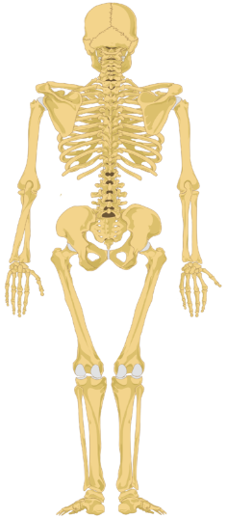Mr Wiseman - Laboratory Technician (Physics)

Mrs Davis - Laboratory Technician

**Key Stage 3**

Key stage 3 Science is taught in Year 7 and 8 and the first term of Year 9.

**Year 7 topics** Cells and microscopes The Skeleton

The Particle model Light

Space Waves

Reproduction Acids and alkalis

Atoms, elements and compounds Forces

Pure and Impure Substances Nutrition and Digestion

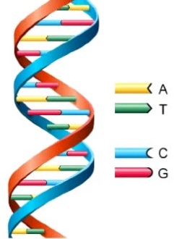**Year 8 topics** Current electricity Health

Pure and Impure Substances Periodic Table

Pressure in fluids Materials

Static electricity Photosynthesis

Forces and motion Relationships in an ecosystem

Gas exchange systems Cellular respiration

Earth and Atmosphere Energy transfers and changes

Inheritance, chromosomes, DNA and genes

**Year 9**

In Year 9 we are introducing the new GCSE AQA Combined Science (Trilogy) course. For more information please refer to the Year 9 Course Option booklet.

**Spanish**

All the teaching in Year 7 takes place in mixed ability groups to allow students to settle into their new school. However, from year 8 onwards, they are taught in sets based on their achievement at the end of Year 7. Sets are reviewed on a termly basis.

**Staff**Ms Santa Barbara - Head of Spanish

Mr Porto-Prado

**Key Stage 3**

**Year 7 Topics** Introducing yourself

Family members and pets

Personal descriptions

Talking about school: subjects and description of Bullers Wood

Telling the time

Describing your house and your area

**Year 8 Topics** Places in town and describing your city

The weather

Sports and free time

Helping at home

Talking about activities in the past

**Year 9 Topics** Visiting a friend abroad

Food and tapas

Shopping: clothes and food

Holidays and tourism (present and past)

