Bullers Wood School
Sixth Form
Be part of our success story
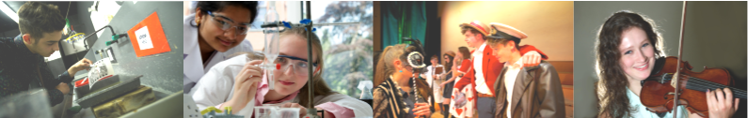

Physical Education A Level

Why study this subject?
Do you actively take part in sport to a good standard and do you have a passion for sport and its science and philosophy? The A Level PE specification provides breadth and balance, giving students the chance to study a wide array of theoretical areas that underpin Physical Education, whilst also getting the chance to experience and develop an interest in a variety of roles and activities. Under the four main titles of Physiology, Sports Psychology, Skill Acquisition and Sport in Society, the theoretical aspects of the AQA specification allow students to build on their knowledge from previous study and learn about factors that optimise performance. The course will enhance students' existing interest in sport as well as further develop the understanding of scientific related components of sport and contemporary issues in technology and in the media.

Entry Requirements
Students need to gain five A*-C grade GCSEs including English and Mathematics at grade 4 a B grade in a Science subject, plus a B grade in PE if studied. A background in port and evidence of ability will also be required.

Content
You will follow a two year A Level course which consists of three units:
- Paper 1: Factors affecting participation in physical activity and sport
Students will complete a two hour written exam, assessing Applied Anatomy and Physiology; Skill Acquisition; and Sport and Society

- Paper 2: Factors affecting optimal performance in physical activity and sport
Students will complete a two hour written, assessing Exercise Physiology and Biomechanics; Sport Psychology; Sport and Society and Technology in Sport

- Practical performance in physical activity and sport
Students will be assessed as a performer or coach in the full sided version of one activity and also complete a written or verbal analysis of performance.

Future courses and possible careers
Students have gone on to study Physiotherapy, Medicine, Biochemistry, Physical Education Teaching, Radiotherapy, Personal Training, Sports Coaching, Sports Development and Sports Journalism.

