

**Direct To Parent Guide**

# Overview

The Direct to Parent supply solution gives parents the ability to order Uniform and PE Kit 24 hours a day via online the SWI ordering system. Orders can be placed either online, by phone or post. We offer a school and home delivery service as well as an easy Returns System

# How to Order

Parents/students can place their orders:

1. **Online**: [www.swidtp.co.uk](http://www.swi.co.uk)
2. **Phone**: 01928 752 610
3. **Post**:   
   Sportswear International Ltd, Fairoak Lane, Whitehouse Industrial Estate, Runcorn,WA7 3DU

**Online Ordering**

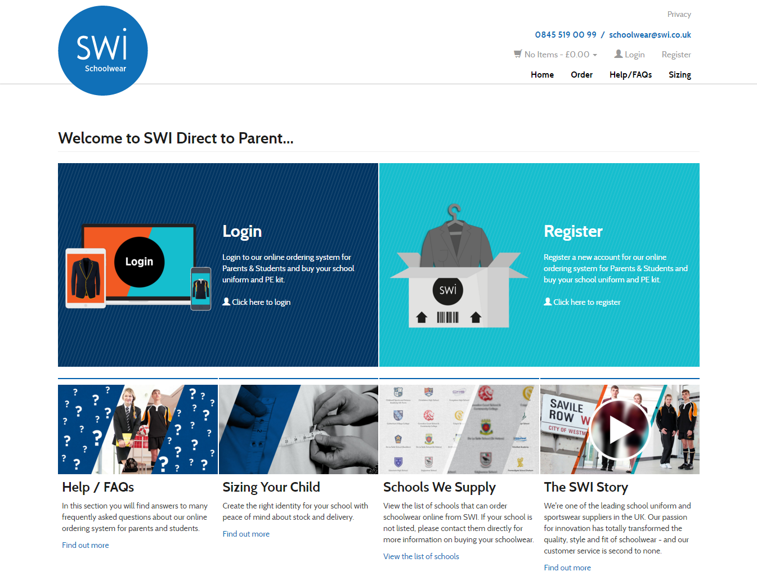

Ordering online couldn’t be easier. Simply visit our website [www.swidtp.co.uk](http://www.swidtp.co.uk/) and choose to either login or register a new account.

New customers will be asked to register and follow the online instructions to link their account to a chosen school. Once you are registered you can begin to order straight away.

All of the Uniform and PE Kit products will be displayed with an indication if the product is compulsory or optional.

# Adding items to the basket

To add an item to your basket, click on the picture or the name of the product then select the size required from the drop down menu and click ***Add to Basket*** button.

Simply type the quantity you wish to order into the quantity box which will automatically update. Once all items have been added to the basket click ***View Basket*** button.

**Basket**

You will be taken to the basket page to confirm your order.

Quantities can be increased / decreased within this screen.

Should an item need to be removed from the order click ***Red Remove*** button.

**Delivery Notes**

If the parcel is to be delivered to home these are the notes that you would like us to pass on to the carrier company if you are not home when they come to make the delivery e.g. Leave with in porch, Leave with neighbours etc.

If the parcel is being delivered into school simply type the child’s name.

Once delivery notes have been entered click onto ***Green Checkout Now*** button.

**Delivery Options**

Select delivery option then click ***Green Confirm Delivery Method*** button.

**Payment**

Payment can be made by Visa, MasterCard, Solo, Maestro.

Unfortunately we do not accept **American Express.**

Once you have made payment you will be given an order reference number.

Please print this page for your records.

Click ***Green Continue Checkout*** button.

**Order Confirmation**

You are now ready to complete your order. Please review your order below, and then click the ***Green Place Order*** button only once to process your order.

**Order Completed**

Once the order is complete you will receive and order number and email confirmation.

**Phone and Postal Orders**

The school will have paper order forms and a downloadable copy on the school website. If you wish to pay by cheque or do not have access to the internet then you can phone or post your order using the paper order form.

**Home Delivery Charges**

* Orders over £70 are sent to home free of charge
* Orders under £70 sent to a home address (or other specified) incur a £4.00 delivery charge
* Orders sent to school are free of charge (see below)

**Delivery into School**We operate a free of charge delivery service into school every week during term time. Orders must be placed by 5pm on the Tuesday for delivery into school the following Thursday for collection on Friday. This allows parents to avoid the delivery charge and makes it easy for students to collect their order from within the school.

**Returns Procedure**

In every dispatch we include a form with full details of how to send items back for a refund.

We offer a 30 day returns policy. Full terms and conditions can be found on our website.

# Web Helpdesk

SWI has a dedicated Web Helpdesk. If you are having difficulty with your online account or logging in then please contact the Team on 0845 519 00 99.